Practice Questions – Microsoft Power Platform (PL-900)

Question 1
A company uses Microsoft Power Platform.
You need to enable users to ask questions with natural language phrases.
Which two Microsoft Power Platform components should you use?
(Each correct answer presents a complete solution.)
- A. Power Apps
- B. Power BI
- C. Power Automate
- D. Microsoft Copilot Studio

Question 2
A company plans to create an app by using Microsoft Power Platform.
The app should be able to email sales quotes to customers.
You need to automate the process of sending sales quotes.
What should you use?
- A. Power Apps
- B. Power Automate
- C. Power BI
- D. Microsoft Copilot Studio

Question 3
A company uses Microsoft Power Platform to manage support activities.
Support technicians must be notified by email when a new support request is created.
You need to recommend the appropriate tool to meet this requirement.
Which tool should you recommend?
- A. Power BI
- B. Power Pages
- C. Power Automate
- D. AI Builder

Question 4
A company plans to use Microsoft Power Platform to transform its business.
The company wants to digitize its invoice approval process to remove all manual steps.
You need to recommend the appropriate Microsoft Power Platform product.
Which product should you recommend?
- A. Power BI
- B. Power Apps
- C. Power Automate
- D. Power Pages

Question 5
A company uses Dynamics 365 Sales to manage its sales process.
Sales managers need access to more detailed analytics than what is available in Sales.
You need to identify which Microsoft Power Platform application creates the required analytics reports.
Which application should you select?
- A. Power Apps
- B. Power BI
- C. Power Automate
- D. Microsoft Copilot Studio

Question 6
A company uses Dynamics 365 Field Service to support their customers.
You need to allow external users to create a new support request.
Which Microsoft Power Platform component should you use?
- A. Power Apps
- B. Power Automate
- C. Power Pages
- D. Power BI

Question 7
A company has a Power Pages site.
You need to send a notification each week by using a third-party service. The notification must contain a summary of the records created inside Power Pages.
Which Microsoft Power Platform component should you use?
- A. Power BI
- B. Power Automate
- C. Microsoft Copilot Studio
- D. Microsoft Dataverse

Question 8
You have a Power Platform environment.
You need to create a canvas app that meets the following requirements:
- Can be published in Microsoft Teams
- Connects to data from three different sources
- Supports up to 1,000 concurrent users
What should you use?
- A. Power Apps mobile app
- B. Microsoft Power Apps Studio
- C. Dataverse
- D. Power Apps maker portal

Question 9
You have a Microsoft Excel file that contains employee expense information. The file is updated daily.
You need to create a cloud flow that runs automatically every time the file is updated.
What should you use to trigger the flow?
- A. Power Apps trigger
- B. OneDrive trigger
- C. Manual trigger
- D. Scheduled trigger

Question 10
You are evaluating Power Automate.
You have:
- A desktop computer (always on during work hours)
- A laptop (used occasionally)
You need to ensure workflows run on the desktop computer even when the laptop is off.
What should you do?
- A. Install Power Automate Desktop and register the desktop
- B. Install a gateway
- C. Use Azure proxy
- D. Use Task Scheduler

Question 11
A real estate company plans to use Microsoft Dataverse to track apartments.
You need to create a column to store whether an apartment is:
- Available for rent
- Available for sale
- Both
Which column type should you use?
- A. Choice
- B. Choices
- C. Yes/No
- D. Text

Question 12
You plan to create a data model by using Microsoft Dataverse.
You have a column that allows users to select:
- Approve
- Reject
You must allow adding more options later.
Which type of column should you create?
- A. Choice
- B. Choices
- C. Yes/No
- D. Text

Question 13
You have a table in Microsoft Dataverse that contains data.
You need to modify the table schema.
What should you do?
- A. Change column data type
- B. Modify display name of a column
- C. Rename schema name
- D. Change ownership

Question 14
You have a canvas app connected to Dataverse.
You create a business rule with these actions:
- Set column values
- Show error messages
- Set requirement levels
- Show recommendations
Which action will NOT execute in a canvas app?
- A. Set column values
- B. Show error messages
- C. Set requirement levels
- D. Show recommendations

Question 15
A user creates a canvas app and wants to share it.
You must follow the principle of least privilege.
Which role should be assigned?
- A. System Administrator
- B. Environment Maker
- C. System Customizer
- D. Global Admin

Question 16
You need to restrict access to social media connectors.
What should you configure?
- A. Security roles
- B. DLP policy
- C. Licensing
- D. Security group

Question 17
You need to prevent external data leakage.
What should you do?
- A. Create data policies
- B. Enable auditing
- C. Use Conditional Access
- D. Install CoE toolkit

Question 18
You need an environment strategy:
- Users can create apps
- Apps must be reviewed before production
- Minimize environments
What should you recommend?
- A. One production environment
- B. Developer + Production environments
- C. Multiple sandbox environments
- D. Only sandbox

Question 19
You must ensure users cannot access Dataverse outside your tenant.
What should you configure?
- A. DLP policy
- B. Conditional Access
- C. Security role
- D. License

Question 20
You need users to read/write data from:
- SharePoint
- OneDrive
What should you use?
- A. Model-driven app
- B. Canvas app
- C. Power Pages
- D. Business process flow

Question 21
You build a guest check-in app.
Requirements:
- Capture name, meal choice, preferences
- Show message if meal unavailable
What should you do?
- A. Use edit form + formula validation
- B. Create new app
- C. Add column
- D. Use OnSubmit

Question 22
You need a canvas app using a Dataverse table with minimal effort.
What should you do?
- A. Create model-driven app
- B. Create blank canvas app and connect
- C. Use template
- D. Add canvas page to existing app

Question 23
You use a custom connector to access a private backend.
External users must access it.
What should you create?
- A. VPN
- B. Guest accounts
- C. On-premises data gateway
- D. Proxy

Question 24
You need an app that:
- Captures images
- Supports CRUD operations
What should you create?
- A. Model-driven app
- B. Canvas app
- C. Power BI
- D. Desktop flow

Question 25
Which two data sources can be used WITHOUT premium connectors?
- A. Excel in OneDrive
- B. Word file
- C. SharePoint list
- D. SQL Server

Question 26
You need to set label text color to red.
Which three methods can achieve this?
- A. Color picker
- B. Formula bar
- C. Advanced properties
- D. Fill property

Question 27
You need to format currency with two decimals.
Which code should you use?
- A. Text(value, format)
- B. Value()
- C. Match()
- D. PlainText()

Question 28
You need users to edit records in a table.
Which control should you use?
- A. Gallery
- B. Edit form
- C. Data table
- D. Container

Question 29
You need to display:
- Product code
- Description
- Image
Which control?
- A. Form
- B. Gallery
- C. Dropdown
- D. Data table

Question 30
Which are features of model-driven apps? (Choose three)
- A. Responsive UI
- B. Embed Power BI
- C. Business process flows
- D. Multiple data sources

Question 31
You need a backend app with:
- Dataverse
- Process guidance
What should you use?
- A. Canvas app
- B. Model-driven app
- C. Power Pages
- D. Desktop flow

Question 32
Users cannot see a new column in a model-driven app.
What should you do? (Choose two)
- A. Add to form
- B. Publish customizations
- C. Add to view
- D. Restart app

Question 33
You need to show job titles in a contact list.
What should you modify?
- A. Contact form
- B. Contact view
- C. Account form
- D. Sitemap

Question 34
You need to cancel outdated appointments daily.
Which trigger?
- A. Manual
- B. Automated
- C. Scheduled
- D. Button

Question 35
You need to trigger a desktop flow from a cloud flow.
What must you do?
- A. Register machine
- B. Use gateway
- C. Use scheduler
- D. Run manually

Question 36
You need parallel execution in a process.
What should you use?
- A. Business rule
- B. Cloud flow
- C. Desktop flow
- D. BPF

Question 37
You need to reuse connectors with minimal effort.
What should you create?
- A. Blank flow
- B. Template flow
- C. Solution
- D. Instant flow

Question 38
You need to send email when SharePoint item is created.
Which two components?
- A. Power Apps
- B. Power Automate
- C. Connectors
- D. Power BI

Question 39
You need to process files on an on-prem server.
What flow type?
- A. Cloud flow
- B. Desktop flow
- C. Scheduled flow
- D. BPF

Question 40
You need to send an email in a flow.
What should you use?
- A. Trigger
- B. Action
- C. Condition
- D. Loop

Question 41
You need a daily automated process.
Which flow?
- A. Instant
- B. Automated
- C. Scheduled
- D. Desktop

Question 42
You need to send email when a flow fails.
What should you configure?
- A. Retry policy
- B. Run after
- C. Compose
- D. Trigger

Question 43
You need to post message when video uploaded.
What flow type?
- A. Instant
- B. Scheduled
- C. Automated
- D. BPF

Question 44
What is a use case for Power Pages?
- A. Analytics
- B. Data capture from customers
- C. Automation
- D. Bot conversations

Question 45
Which templates accelerate Power Pages creation? (Choose two)
- A. Starter
- B. Solution
- C. Blank
- D. Dynamics

Question 46
You need a self-service portal for customers.
What should you use?
- A. Canvas app
- B. Model-driven app
- C. Power Pages
- D. Power BI

Question 47
What must you do FIRST to create a Power Pages site?
- A. Create Dataverse environment
- B. Configure DNS
- C. Create flow
- D. Add users

Question 48
Which URL is used to create Power Pages sites?
- A. make.powerapps.com
- B. make.powerautomate.com
- C. make.powerpages.microsoft.com
- D. app.powerbi.com

Question 49
After importing a Power Pages solution, what should you do?
- A. Publish site
- B. Configure site
- C. Create new site
- D. Re-import

Question 50
How do you move a Power Pages site?
- A. Export/import solution
- B. Copy site
- C. Recreate site
- D. Export database

Topics based questions

Power apps
1. What is the primary data source for building model-driven apps in Power Apps?
Microsoft Dataverse
Excel spreadsheets
SQL databases
2. A business owner wants to ensure that customer service requests are handled consistently across their team. Which logic component should they use?
Business process flow
Workflow
Business rule
3. What is the primary purpose of a form in a model-driven app?
To allow users to view, create, and edit data stored in Microsoft Dataverse tables.
To manage user permissions and access levels within the app.
To generate reports and analytics from the stored data.
4. A team in an organization needs access to a model-driven app. What is the best way to ensure all team members inherit the same privileges?
Assign a security role to the team instead of individual users.
Share the app link with each team member individually.
Create a custom security role for each team member.

Power Automate
1. In the context of process mining in Power Automate, which scenario best illustrates the identification of a bottleneck in a workflow?
An increase in customer satisfaction after process optimization
A delay in invoice processing due to multiple manual reviews
The implementation of a new automated task to improve efficiency
2. Which component would you use to perform tasks like sending emails or updating records in Power Automate?
Action
Connector
Trigger
3. Why would a user choose a cloud flow template over creating a flow from scratch in Power Automate?
To eliminate the need for user input in workflow execution.
To ensure compatibility with on-premises applications.
To save time and reduce complexity by using preconfigured workflows.
4. In a Power Automate cloud flow, which feature allows you to perform different actions based on the value of a data field?
Branching
Loops
Triggers
5. In Power Automate's process mining, what type of data is primarily analyzed to understand and optimize business workflows?
Customer satisfaction surveys
Event data from systems of record
Financial statements
6. How does process mining enhance business workflow analysis in Power Automate?
By automating tasks based on real-time data updates
By integrating seamlessly with desktop applications
By providing a visual representation of actual process flows using event data
7. Which scenario is most suitable for using a cloud flow template in Power Automate?
When you need to write custom code for a unique automation task
When you need a quick start with a prebuilt flow that can be customized
When integrating legacy desktop applications with cloud services
8. Your organization needs to automate customer support ticket management by integrating Microsoft Teams and SharePoint. Which Power Automate component can enable this integration to streamline workflows and enhance team communication?
Triggers
Loops
Connectors
9. Your company uses a standardized process for handling customer returns. However, delays in processing returns have been reported. How can process mining in Power Automate help identify the root cause of these delays?
By visualizing the actual flow of the return process and identifying bottlenecks
By sending alerts to managers when delays exceed set thresholds
By automatically rerouting returns to available personnel

Canvas Apps

ich role should be assigned to a team member who needs to both edit and share a canvas app but not delete it?
Administrator
User
Co-Owner
2. You are tasked with developing a canvas app using existing Excel data stored in OneDrive for Business. What is the crucial step to ensure the app can read and write data successfully from this Excel file?
Ensure the Excel file is open in Excel Online during app development.
Store the Excel file in the root directory of OneDrive for Business for access.
Format the Excel data as tables within the spreadsheet.
3. Which data source in Power Apps is most suitable for building an app with complex data relationships and a high number of users?
SharePoint
Microsoft Dataverse
Excel
4. Which step is essential when using Excel as a data source for a Power Apps canvas app to ensure data availability?
Lock the Excel file to prevent modifications
Embed Excel macros for enhanced functionality
Ensure the Excel file is stored in OneDrive or SharePoint for accessibility
5. Which data source is most likely to face performance issues in Power Apps when handling large datasets without proper optimization?
SQL Server
SharePoint
Microsoft Dataverse
6. How does Agent Builder enhance business process automation in a Power Apps canvas app?
By providing templates for manual data entry processes
By creating AI-driven agents that automate tasks based on app metadata
By integrating additional manual workflows into the app
7. You have developed a canvas app and want to ensure its functionality before making it available to users. Which step should you take to test the app thoroughly in Power Apps Studio?
Use the Preview mode to interact with the app as an end-user would.
Manually check each formula for syntax errors in the development environment.
Publish the app and solicit feedback from users after deployment.
8. Which data source is recommended for a small-scale Power Apps solution that does not require complex relationships and is cost-effective?
SharePoint
SQL Server
Microsoft Dataverse
9. You're developing a canvas app that includes Copilot controls for user interaction. What is a primary benefit of using Copilot controls in your app?
Providing users with the ability to interact with the app using natural language queries.
Ensuring the app's design is consistent across different devices.
Automatically generating data sources based on user input.

1.
How does process mining in Power Automate facilitate the comparison of different workflow versions to determine efficiency?

By generating visual process maps that highlight variations and performance metrics
Correct
By providing alerts for non-compliant workflows
By automatically selecting the most efficient workflow for implementation
2.
How can process mining in Power Automate help a company improve its invoice processing workflow?

By identifying bottlenecks and inefficiencies in the current process using real data analysis.
Correct
By integrating all invoice-related applications into a single platform.
By automatically approving invoices that meet specific criteria.
3.
Why would a user choose a cloud flow template over creating a flow from scratch in Power Automate?

To eliminate the need for user input in workflow execution.
To save time and reduce complexity by using preconfigured workflows.
Correct
To ensure compatibility with on-premises applications.
4.
While automating a desktop task, you need the flow to continue only if a certain application is open. Which Power Automate for Desktop feature should you use?

Loops
UI automation
If condition
Correct
5.
Which scenario is most suitable for using a cloud flow template in Power Automate?

When you need a quick start with a prebuilt flow that can be customized
Correct
When you need to write custom code for a unique automation task
When integrating legacy desktop applications with cloud services
6.
Which outcome can be expected after utilizing process mining to compare workflows within an organization?

Automatic correction of all identified inefficiencies
Adoption of best practices from the most efficient workflow
Elimination of the need for manual oversight in all processes
Incorrect
7.
Your organization finds discrepancies between documented workflows and actual practices. How can process mining in Power Automate assist in addressing this issue?

By automatically updating documentation to match actual workflows
By revealing the actual flow of processes and highlighting deviations from documented workflows
Correct
By providing templates to standardize workflows
8.
A company wants to automatically save email attachments from a specific sender to a SharePoint folder. Which Power Automate components are essential to achieve this?

Actions and approvals
Triggers and connectors
Triggers, actions, and connectors
Correct
9.
Your organization wants to automate the process of responding to customer feedback received through Microsoft Forms. Which Power Automate component would best facilitate this automation?

Approval flow
Desktop flow
Cloud flow
Correct

Power Pages
What is the primary function of table permissions in Power Pages?

To grant or deny access to individual pages on the website.
To manage business data for your site, including content such as text, images, videos, and forms.
To define access to rows in Dataverse tables regardless of how and where they are accessed in Power Pages.
2.
An external partner is unable to access the collaboration portal on your Power Pages site, despite having proper credentials. What is the likely cause?

Table permissions are configured for external users
Site visibility is set to public
Page permissions are not set correctly for the partner's web role
3.
What is a key benefit of using external identity providers for Power Pages authentication?

Simplified user interface design
Faster data processing speeds
Enhanced security with reduced dependency on local credentials
4.
What is a primary advantage of using the AI-powered Copilot feature in Power Pages for site creation?

It enhances site security through automated permission settings.
It streamlines the site's initial setup, allowing for rapid development and customization.
It provides pro-code tools for advanced site customization.
5.
Which security feature in Power Pages ensures that only specific users can access particular web pages?

Page permissions
Web roles
Table permissions
6.
A company wants to ensure that only authenticated users can access its Power Pages site. Which authentication method should they choose?

Local sign in with forms-based authentication.
Integration with Power Automate.
Public site visibility.
7.
Your company wants to launch a new website quickly to offer a self-service portal for customers. You have limited coding expertise and need to create the site efficiently. Which Power Pages feature should you use for an intuitive and fast site setup?

AI-powered Copilot
Design studio
Developer environment
8.
When using the AI-powered Copilot to create a Power Pages site for your organization, which component is NOT automatically generated by Copilot?

Site name
Custom data integrations
Homepage layout
9.
Your organization wants to automate workflow processes while ensuring data consistency across platforms. Which Power Pages feature should you leverage to achieve this goal?

Customizable templates for creating unique site designs.
Integration with Power Automate to streamline workflows.
External authentication with social media accounts.

1.Your organization uses Power Pages for customer self-service portals. If external identity providers are not configured, what is the potential security vulnerability?

Increased risk of unauthorized access
Limited data accessibility
Slower website performance
2. How can Power Pages help a retail company struggling with customer inquiries and outdated systems?

By developing a new mobile app for customers to place orders.
By creating a customer self-service portal for quick issue resolution and personalized experiences.
By replacing all existing systems with Power Pages.
3. Your organization needs to manage who can access your Power Pages site and what data they can view or edit. Which security model component should you implement?

Web roles and table permissions.
External authentication with identity providers.
AI-powered site creation tools.
4. What is a key advantage of using Power Pages' design studio for creating business websites?

It offers pre-built customizable templates and a low-code environment for quick site creation.

It is only suitable for experienced developers and requires extensive programming knowledge.
It requires advanced coding skills to implement custom designs.
5. A company wants to ensure that only authenticated users can access its Power Pages site. Which authentication method should they choose?

Integration with Power Automate.
Public site visibility.
Local sign in with forms-based authentication.
6. Which security feature in Power Pages ensures that only specific users can access particular web pages?

Web roles
Page permissions
Table permissions
7. Your company wants to enhance communication with suppliers and partners. Which Power Pages solution would best address this need?

Employee self-service platform
Partner collaboration site
Customer self-service portal
8. Which Power Pages security component is responsible for managing user authentication?

Web roles
Identity providers
Page permissions
9. Which security feature in Power Pages helps in controlling access to individual webpages on a site?

Page permissions.
External authentication providers.
Web roles.

n the Power Platform, which environment type is best suited for creating and testing apps without affecting production data?

Sandbox
Correct
Production
Default
2.
Which environment type in Power Platform is automatically created for each tenant and shared by all users?

Production
Developer
Default
Correct
3.
Which administrative portal is primarily used for creating and managing Power BI reports and dashboards within the Power Platform ecosystem?

Power BI portal
Correct
Power Apps maker portal
Microsoft Entra ID portal
4.
Which Power Platform environment type is designed for nonproduction purposes like development and testing?

Sandbox
Trial
Production
Incorrect
5.
What is the primary function of Data Loss Prevention (DLP) policies within the Power Platform?

To control how data flows between business and non-business connectors
Correct
To encrypt data in both rest and transit
To control user access to specific application features
6.
Which environment type in Power Platform is not intended for long-term work and expires after a set period?

Production environment
Sandbox environment
Trial environment
Correct
7.
Your organization needs to manage multiple environments and ensure consistent application of governance policies. Which feature of the Power Platform should be utilized to achieve this goal?

Data Loss Prevention (DLP) Policies
Incorrect
Managed Environments
Microsoft Entra ID
8.
Which maker portal is used for creating and managing Power BI reports and dashboards?

https://app.powerbi.com
Correct
https://make.powerapps.com
https://make.powerautomate.com
9.
An organization wants to ensure that only users in specific regions can access certain sensitive data within their Power Platform environment. Which feature should they implement to achieve this goal?

Environment security
Incorrect
Conditional access policies
Data encryption

Question 1 of 50
A company uses Microsoft Power Platform.
You need to enable users to ask questions with natural language phrases.
Which two Microsoft Power Platform components should you use? Each correct answer presents a complete solution.
Your Answer
- Microsoft Copilot Studio
This answer is correct.
- Microsoft Dataverse
This answer is incorrect.
Correct Answer
- Power BI
This answer is correct.
- Microsoft Copilot Studio
This answer is correct.
This item tests the candidate’s knowledge of the business value of Power BI and Microsoft Copilot Studio.
The Q&A feature in Power BI dashboards allows users to ask questions of their data using natural language and creates new visualizations based on the question and data. Microsoft Copilot Studio bots can understand the phrases supplied by users in natural language and can determine the topic and conversation to be used to respond to the user. Power Automate and Microsoft Dataverse do not include a user interface that permits users to ask questions.
Manage the Microsoft Power Platform environment- Training | Microsoft Learn
Q&A for Power BI business users - Power BI | Microsoft Learn
Use topics to design a chatbot conversation - Power Virtual Agents | Microsoft Learn
Question 2 of 50
A company plans to create an app by using Microsoft Power Platform.
The app should be able to email sales quotes to customers.
You need to automate the process of sending sales quotes.
What should you use?
Your Answer
- Power Automate
This answer is correct.
Correct Answer
- Power Automate
This answer is correct.
The item tests the candidate’s knowledge of using Power Automate to automate processes.
With Power Automate, email notifications can be sent with attachments. Power Apps allows creating complex user interfaces with cross-browser and cross-device compatibility. Power BI is used for analytics and provides insights with interactive visualizations. Microsoft Copilot Studio allow users to build bots for support scenarios. Power Apps, Power BI, and Microsoft Copilot Studio cannot be used to send automated emails.
Manage the Microsoft Power Platform environment- Training | Microsoft Learn
Power Automate documentation - Power Automate | Microsoft Learn
Question 3 of 50
A company is evaluating Microsoft Power Platform.
The company needs to send out a reminder to specific teams to complete their timesheet. The reminder should be sent on Wednesday and Friday every week.
You need to determine which Microsoft Power Platform tool to use.
What should you use?
Your Answer
- Power Automate
This answer is correct.
Correct Answer
- Power Automate
This answer is correct.
The item tests the candidate’s knowledge of Microsoft Power Platform services and the business scenarios where they can be used.
Scheduled cloud flows in Power Automate can be used to send reminders to users every week. Power BI is used to create reports and dashboards. Power Apps provides a way of quickly creating online forms and applications that are low-code solutions. Microsoft Copilot Studio is used to create bots for support scenarios.
Manage the Microsoft Power Platform environment- Training | Microsoft Learn
Microsoft Power Platform documentation - Power Platform | Microsoft Learn
Question 4 of 50
A company uses Microsoft Power Platform to manage support activities.
Support technicians must be notified by email when a new support request is created.
You need to recommend the appropriate tool to meet this requirement.
Which tool should you recommend?
Your Answer
- Power Automate
This answer is correct.
Correct Answer
- Power Automate
This answer is correct.
This item tests the candidate’s knowledge of how Power Automate can be used to meet a specific need.
Power Automate is a service that helps create automated workflows between apps and services to synchronize files, get notifications, and collect data. Power Automate has built-in connectors to send emails. For example, the Office 365 Outlook connector can be used to send email notifications by using Outlook.
Power Pages is a SaaS platform for creating, hosting, and administering external-facing business websites with data from Dataverse. This platform cannot be used to send automated email notifications.
Power BI is an analytical platform for visualizations that uses data from multiple sources. This platform cannot be used to configure email automations.
AI Builder is used to create and train models to analyze data by using AI. Microsoft Power Platform has prebuilt AI Builder models. There is also the option to create custom models. AI Builder cannot be used to configure email automations.
Manage the Microsoft Power Platform environment- Training | Microsoft Learn
Trigger a cloud flow based on email properties
Question 5 of 50
A company hosts conferences.
You need to enable customers to view upcoming conferences hosted by your company.
Which Power Apps component should you use?
Your Answer
- Power Pages
This answer is correct.
Correct Answer
- Power Pages
This answer is correct.
This item tests the candidate’s knowledge of selecting Power Apps components.
Power Pages allow you to create a website for external users. Canvas apps, model-driven apps, and business process flows are not suitable for external users.
Get started building with Power BI - Training | Microsoft Learn
Start building apps - Power Apps | Microsoft Learn
Question 6 of 50
A company uses a third-party customer service solution. The solution is on-premises and uses Microsoft SQL Server as the data store.
You need to show the customer service data in a canvas app.
What should you use?
Your Answer
- Connector
This answer is correct.
Correct Answer
- Connector
This answer is correct.
The item tests the candidate’s knowledge of how to consume data from third-party apps. Identifying the right component to fetch data from an external source is a fundamental skill to understand the business value of Microsoft Power Platform.
The SQL server connector can be used to connect to Microsoft SQL Server databases and perform CRUD operations. AI Builder is a tool for creating models and classification that can add intelligence to apps and flows. Microsoft Copilot Studio allows users to create bots for support scenarios. Power BI is used for analytics and creating visualizations. AI Builder, Microsoft Copilot Studio, and Power BI cannot be used to fetch data from an external Microsoft SQL Server database.
Manage the Microsoft Power Platform environment- Training | Microsoft Learn
Power Platform connectors overview | Microsoft Learn
Question 7 of 50
A company uses Microsoft Power Platform. The company builds Power Apps canvas apps, Power BI dashboards, and Microsoft Copilot Studio.
You need to identify the Microsoft Power Platform component that can be used directly with these three components.
What should you identify?
Your Answer
- Microsoft Dataverse
This answer is incorrect.
Correct Answer
- Power Automate
This answer is correct.
This item tests the candidate’s knowledge of how Microsoft Power Platform components work together.
Manage the Microsoft Power Platform environment- Training | Microsoft Learn
https://learn.microsoft.com/training/modules/introduction-power-platform/
Create a canvas app that can trigger a Power Automate flow (contains video) - Power Apps | Microsoft Learn
Integrate Power BI data alerts with Power Automate - Power BI | Microsoft Learn
Use Power Automate flows in Power Virtual Agents - Power Virtual Agents | Microsoft Learn
Question 8 of 50
A company has a Power Pages.
You need to send a notification each week by using a third-party service. The notification must contain a summary of the records created inside the Power Pages.
Which Microsoft Power Platform component should you use?
Your Answer
- Power Automate
This answer is correct.
Correct Answer
- Power Automate
This answer is correct.
This item tests the candidate’s knowledge of which component can be used to integrate with third-party services and Microsoft Power Platform.
Power Automate can use the standard connector or custom connectors to connect to third-party services. Power BI is a business analytics service. Microsoft Copilot Studio is used to create chatbots, not to consume third-party services. Microsoft Dataverse is a data platform.
Manage the Microsoft Power Platform environment- Training | Microsoft Learn
Frequently asked questions - Power Automate | Microsoft Learn
Question 9 of 50
You have a Microsoft Excel file that contains employee expense information. The file is updated daily.
You need to create a cloud flow that runs automatically every time the file is updated.
What should you use to trigger the flow?
Your Answer
- a Microsoft OneDrive trigger
This answer is correct.
Correct Answer
- a Microsoft OneDrive trigger
This answer is correct.
The correct answer is a Microsoft OneDrive trigger because it allows the flow to automatically run when the file stored in OneDrive is modified, which matches the requirement of reacting to file updates. A OneDrive action is used after a trigger to perform operations but cannot initiate the flow. A Power Apps action or trigger would require a user to manually start the flow from an app, which does not satisfy the requirement for automation on file updates.
Create a cloud flow in Power Automate
Triggers overview
Question 10 of 50
You have a Power Platform environment that contains the following Microsoft Dataverse tables:
- Account: Standard table, part of a managed solution
- Product: Custom table, part of an unmanaged solution
- Sales Order: Custom table, part of a managed solution
You need to implement a new table named Invoice. The solution must meet the following requirements:
- Invoice must be associated with a standard table.
- Invoice must be associated with an existing custom table.
- Administrative effort must be minimized.
Which tables can you associate with Invoice?
Your Answer
- Account, Product, and Sales Order
This answer is correct.
Correct Answer
- Account, Product, and Sales Order
This answer is correct.
The correct answer is Account, Product, and Sales Order because the requirement specifies associating the new Invoice table with both a standard Dataverse table and at least one existing custom table. Account is the standard table, while Product and Sales Order are custom tables. There is no restriction preventing association with both managed and unmanaged custom tables, and including all three minimizes administrative effort by satisfying both requirements in a single configuration. Options that only include subsets of these tables (such as Account only or Product and Sales Order only) fail to meet the full requirement.
Create a relationship between tables
Question 11 of 50
You build a solution by using Microsoft Power Platform and Microsoft Dataverse.
You must use the default Currency table that comes with Microsoft Dataverse.
You need to determine the table type for the Currency table.
Which table type should you identify?
Your Answer
- Standard
This answer is correct.
Correct Answer
- Standard
This answer is correct.
This item tests the candidate’s knowledge of the types of Microsoft Dataverse tables.
Several standard tables, also known as out-of-the-box tables, are included with a Microsoft Dataverse environment. The Currency table is one of those tables. An activity table holds the type of information for which an entry can be made on a calendar. The Currency table is not an activity table or an elastic table. In this scenario, an out-of-the-box table is being used, so it is not custom. A virtual table is a custom table that has columns containing data from an external data source. In this scenario, external data is not being accessed and a virtual table is not required.
Manage the Microsoft Power Platform environment- Training | Microsoft Learn
Types of tables - Power Apps | Microsoft Learn
Question 12 of 50
A real estate company plans to use Microsoft Dataverse to track apartments.
You need to create a new column to store whether an apartment is available for rent, for sale, or both.
Which column type you should use?
Your Answer
- Choices
This answer is correct.
Correct Answer
- Choices
This answer is correct.
This item tests the candidate’s knowledge of selecting Microsoft Dataverse column types.
The Choices column type can select multiple options between multiple values. The Choice column type can select only one option between multiple values. The Yes/No column type can select only one option between two values. Customer references to an Account or a Contact. The Text area column type is a free text field and could have any value, not a defined list of values with multi-select.
Manage the Microsoft Power Platform environment- Training | Microsoft Learn
Column data types in Microsoft Dataverse (contains video) - Power Apps | Microsoft Learn
Question 13 of 50
You have a table in a Microsoft Dataverse database that contains data.
You need to modify the table schema.
What should you do?
Your Answer
- Modify the display name of a column.
This answer is correct.
Correct Answer
- Modify the display name of a column.
This answer is correct.
The correct action is to modify the display name of a column, which is a supported way to change a Dataverse table’s schema without breaking dependencies. Changing the data type of an existing column is not supported if the column already contains data because it risks data loss or incompatibility. The concept of an "owner" for a column is not valid in Dataverse; ownership applies to records, not schema elements. Changing the actual name of a column is not allowed after creation, as the schema name is immutable once defined.
Create and edit tables using Power Apps
How to create and edit columns
Question 14 of 50
You have a Microsoft Dataverse environment.
You create a business process flow for a table. The business process flow has three stages.
You also create a business rule that must run whenever the value of a status column changes. The business rule must run after each stage of the business process flow is complete.
You need to ensure the business rule is active and will run as designed.
What should you do?
Your Answer
- In the business process flow, add the business rule as a step.
This answer is incorrect.
Correct Answer
- On the table, activate the business rule.
This answer is correct.
The correct approach is to activate the business rule on the table, because business rules are always defined and enforced at the table level, not inside a business process flow. Activating the rule on the table ensures it runs automatically when the status column value changes, including after each stage of the BPF is completed. Activating a business rule in the business process flow itself is not possible, and adding it as a step in the flow would not trigger the rule properly. Activating the BPF on the table enables the process flow but does not affect whether the business rule executes.
Apply custom business logic with business rules and flows in model-driven apps
Create a business rule for a table
Overview of working with business process flows
Question 15 of 50
You have a canvas app that connects to a Microsoft Dataverse table.
You plan to create a business rule that uses the following actions:
- Set column values
- Show error messages
- Set column requirement levels
- Show recommendations based on business intelligence
You need to identify which action will not execute when the business rule runs from the canvas app.
Which action will be excluded when the business rule runs in the canvas app?
Your Answer
- Create business recommendations based on business intelligence.
This answer is correct.
Correct Answer
- Create business recommendations based on business intelligence.
This answer is correct.
In a canvas app, Dataverse business rules can set column values, show error messages, and set requirement levels because these actions are directly supported at the client level. However, recommendations based on business intelligence only work in model-driven apps and are not executed in canvas apps.
Create a business rule for a table
Question 16 of 50
You have a Power Platform environment that contains a Microsoft Dataverse database.
A user named User1 plans to create a canvas app named App1 that connects to the Dataverse database. User1 will share App1 with other users.
You need to ensure that User1 can share App1. The solution must follow the principle of least privilege.
Which security role should you assign to User1?
Your Answer
- Environment Maker
This answer is correct.
Correct Answer
- Environment Maker
This answer is correct.
The Environment Maker role is the least-privilege security role that allows a user to create apps, flows, and connections and to share apps with others in the environment. The System Customizer and System Administrator roles provide far broader permissions, including customization and administrative rights across the environment, which exceeds the requirements and violates least privilege. Delegated Admin applies to Microsoft partner-managed environments and is not required in this scenario.
Role-based security roles
Role-based security roles
Question 17 of 50
A company uses Microsoft Power Platform.
You need to prevent external leakage of corporate data.
What should you do?
Your Answer
- Create data policies.
This answer is correct.
Correct Answer
- Create data policies.
This answer is correct.
This item tests the candidate’s knowledge of data policies.
Data policies prevent an app or a flow from connecting to two different data sources that may allow data to be accessed or copied outside of the organization. For example, a cloud that connects to both Azure SQL Server and Dropbox could copy the data from Azure SQL Server to an external Dropbox folder. Microsoft Entra ID conditional access can control when a user can access a Power Apps app using various signals such as location and device. It will not prevent data from being leaked externally. The Microsoft Power Platform CoE toolkit will enable monitoring of the apps, flows, and connectors used within your organization. It will not prevent data leakage on its own. The CoE toolkit enables the managing of data policies. Auditing in Microsoft Dataverse captures changes to data in Microsoft Dataverse tables. Auditing does not prevent data leakage.
Manage the Microsoft Power Platform environment- Training | Microsoft Learn
Data loss prevention policies - Power Platform | Microsoft Learn
Plan to deploy ExpressRoute with Microsoft Power Platform - Power Platform | Microsoft Learn
Set up Azure AD Conditional Access - Microsoft Power Platform - Power Platform | Microsoft Learn
Question 18 of 50
A coworker requires a personal Microsoft Power Platform environment to test preview features of Power Apps. The coworker wants to use this environment for at least two months.
You need to recommend which type of environment the coworker should create.
Which type of environment should you recommend?
Your Answer
- Developer
This answer is correct.
Correct Answer
- Developer
This answer is correct.
This item tests the candidate’s knowledge of the Microsoft Power Platform environments.
The developer environment type is intended to be used by its owner and is available as long as it is actively used. The default environment type is automatically provisioned by the system and cannot be created for single users. The production environment type is intended for permanent work, not for testing preview features. The trial environment type is intended for short-term testing but expires after 30 days.
Create and manage environments in Microsoft Dataverse - Training | Microsoft Learn
Environments overview - Power Platform | Microsoft Learn
Dataverse for Teams vs. Dataverse - Power Apps | Microsoft Learn
Question 19 of 50
You have a Power Platform environment.
You need to recommend an environment strategy that meets the following requirements:
- Users must be able to create apps and share them with others.
- All apps must be reviewed before deployment to production.
- The number of environments must be minimized.
What should you recommend?
Your Answer
- Create one developer environment and one production environment that has governance policies.
This answer is correct.
Correct Answer
- Create one developer environment and one production environment that has governance policies.
This answer is correct.
The most effective strategy is to use two environments: a developer environment where users can build and share apps, and a production environment that enforces governance policies and acts as the controlled deployment target. This setup minimizes the number of environments while still allowing proper review and approval processes before production deployment. A single sandbox or developer environment does not support production use, and a single production environment would not provide a staging area for review.
Develop a tenant environment strategy to adopt Power Platform at scale
Question 20 of 50
You plan to create a Power Apps app.
You need to enable users to read and write data from SharePoint and OneDrive for Business.
What should you use?
Your Answer
- A Canvas app
This answer is correct.
Correct Answer
- A Canvas app
This answer is correct.
The item tests the candidate’s knowledge of the difference between canvas apps and model-driven apps and the use cases of the app types.
A canvas app connects to multiple data sources including SharePoint and Excel files stored in OneDrive for Business by using out-of-the-box connectors. Model-driven apps can use only Microsoft Dataverse as the underlying data store. Power Pages allow external customers and partners to access data in Microsoft Dataverse. Business process flows are used to standardize business processes, providing a streamlined UI for users to complete a process. Model-driven apps, Power Apps portals, and Business process flows cannot be used to read and write data from SharePoint and OneDrive.
Get started building with Power BI - Training | Microsoft Learn
Overview of building canvas apps - Power Apps | Microsoft Learn
Overview of building a model-driven app with Power Apps - Power Apps | Microsoft Learn
Question 21 of 50
A company wants to streamline the new employee onboarding process.
You need to allow new employees to manage their active certifications and work history by using an Excel workbook.
Which Power Apps solution should you use?
Your Answer
- Model-driven app
This answer is incorrect.
Correct Answer
- Canvas app
This answer is correct.
This item tests the candidate’s knowledge of selecting Power Apps components.
Canvas apps can access Excel workbooks. Model-driven apps and Power Pages do not work with Excel workbooks. Microsoft Dataverse is a data platform.
Get started building with Power BI - Training | Microsoft Learn
Start building apps - Power Apps | Microsoft LearnCreate a canvas app with data from an Excel file (contains video) - Power Apps | Microsoft Learn
Question 22 of 50
You have a Power Platform environment.
You build a model-driven app named App1 that contains a form displaying multiple fields. Users report that the form loads slowly.
You need to improve the performance of App1.
What should you configure?
Your Answer
- the number of fields in the form
This answer is correct.
Correct Answer
- the number of fields in the form
This answer is correct.
The performance of model-driven app forms is heavily affected by the number of fields, controls, and components loaded at runtime. Reducing the number of fields on the form or using multiple tabs/sections to load data on demand can significantly improve form performance. Security configuration, environment configuration, and general data settings do not directly resolve slow-loading forms in this scenario.
Why choose Microsoft Dataverse?
Best practices and guidance for model-driven apps
Question 23 of 50
You need to create a Microsoft Power Apps app that enables users to capture images and perform full CRUD operations of related data.
What should you create?
Your Answer
- A canvas app
This answer is correct.
Correct Answer
- A canvas app
This answer is correct.
A canvas app is the correct choice because it supports device integration such as the camera control for capturing images and provides full flexibility to build forms that support create, read, update, and delete (CRUD) operations on data stored in Microsoft Dataverse or other connected sources. A model-driven app is optimized for data-driven scenarios but does not provide direct integration with device hardware such as cameras. Power Automate desktop flows are used for robotic process automation (RPA), not for building interactive apps. Power BI apps are designed for analytics and reporting, not for transactional CRUD or image capture.
Create a canvas app based on Excel data
Question 24 of 50
A company uses Microsoft Power Platform.
You need to recommend a use case for formulas in canvas apps.
Which two actions should you recommend? Each correct answer presents a complete solution.
Your Answer
- Filter a list of rows.
This answer is correct.
- Save data when a user selects a button.
This answer is correct.
Correct Answer
- Filter a list of rows.
This answer is correct.
- Save data when a user selects a button.
This answer is correct.
This item tests the candidate’s knowledge of the use cases for formulas.
FILTER is a common formula used in canvas apps to restrict the rows from a data source or collection. The OnSelect property for a button contains the actions to perform. Formulas such as SubmitForm and Patch are used to save data to a data source. Formulas are not used to share a canvas app. Formulas can only be used when building a canvas app. There is no equivalent formula for the WEBSERVICE Excel function that retrieves XML data from an internet URL.
Get started building with Power BI - Training | Microsoft Learn
Get started with formulas in canvas apps - Power Apps | Microsoft Learn
WEBSERVICE function - Microsoft Support
Question 25 of 50
You create and publish a canvas app.
Users report issues with the latest version of the app.
You need to revert the app to an earlier working version.
Which two actions should you perform? Each correct answer presents part of the solution.
Your Answer
- Select an earlier version of the app and click on Restore.
This answer is correct.
- Publish the restored version of the app.
This answer is correct.
Correct Answer
- Select an earlier version of the app and click on Restore.
This answer is correct.
- Publish the restored version of the app.
This answer is correct.
This item tests the candidate’s knowledge of versioning of canvas apps. Understanding version management in canvas apps is fundamental knowledge for anyone who publishes and shares apps.
To restore canvas apps to an earlier version, the Restore option must be used. Once an earlier version of the canvas app is restored, a new version is created. The restored version needs to be published. To restore to an earlier version of the app, the app does not need to be edited and changes do not need to be undone. The Restore option can be used. The app is exported with the latest changes whenever you export a canvas app. The earlier version of the app cannot be exported.
Get started building with Power BI - Training | Microsoft Learn
Restore your canvas app to a previous version - Power Apps | Microsoft Learn
Question 26 of 50
A company uses Microsoft Power Platform.
Which two controls in a canvas app can be connected to a data source? Each correct answer presents a complete solution.
Your Answer
- Form
This answer is correct.
- Gallery
This answer is correct.
Correct Answer
- Form
This answer is correct.
- Gallery
This answer is correct.
This item tests the candidate’s knowledge of controls to design the user experience.
A form is used to view, edit, and create a single row for a data source. To configure a form, you select its data source. A gallery displays a list of rows from a data source. To configure a gallery control you select its data source. A button has a formula that can change the properties of other controls. A button can cause data to be saved but the button is not linked to a data source. A screen is not linked to a data source. The controls added to the screen can be linked to data sources.
Get started building with Power BI - Training | Microsoft Learn
Controls and properties in canvas apps - Power Apps | Microsoft Learn
Question 27 of 50
You create a canvas app that is connected to a Microsoft Dataverse table.
You need to share the app.
Which two actions should you perform? Each correct answer presents part of the solution.
Your Answer
- Allow the users to edit the app.
This answer is incorrect.
- Assign a security role.
This answer is correct.
Correct Answer
- Publish the app.
This answer is correct.
- Assign a security role.
This answer is correct.
This item tests the candidate’s knowledge of sharing a canvas app when users need to edit it.
A canvas app must be published before it can be shared. When a canvas app is connected to a Microsoft Dataverse table, a security role must be assigned. The email is only a notification. It does not affect sharing capabilities. To share an app, it is not required to allow users to edit it.
Get started building with Power BI - Training | Microsoft Learn
Share a canvas app with your organization - Power Apps | Microsoft Learn
Question 28 of 50
You use a Microsoft Dataverse table to store products. You create a canvas app to list the products in the app.
You need to enable users to view the product code, description, and image of each product.
Which control should you use?
Your Answer
- Form
This answer is incorrect.
Correct Answer
- Gallery
This answer is correct.
The item tests the candidate’s knowledge of controls to design UI in canvas apps. Identifying the correct control is a fundamental skill required to build a canvas app.
The Gallery control displays the multiple records from data source and each record can contain multiple types of data including images Forms displays a single record. It cannot be used to show a list of items. The Drop-down control cannot display image column of Dataverse. The Data table control cannot display image column of Dataverse.
Get started building with Power BI - Training | Microsoft Learn
Show a list of items in canvas apps - Power Apps | Microsoft Learn
Question 29 of 50
A company uses Microsoft Power Platform.
You need to identify the features of model-driven apps.
What are three features of model-driven apps? Each correct answer presents a complete solution.
Your Answer
- They adjust the layout of the UI automatically in response to changes in a device’s orientation or screen resolution.
This answer is correct.
- They embed Power BI dashboards.
This answer is correct.
- They guide users by using business process flows.
This answer is correct.
Correct Answer
- They adjust the layout of the UI automatically in response to changes in a device’s orientation or screen resolution.
This answer is correct.
- They embed Power BI dashboards.
This answer is correct.
- They guide users by using business process flows.
This answer is correct.
This item tests the candidate’s knowledge of the capabilities of model-driven apps.
Model-driven apps are based on a single data source, which is Dataverse. Model-driven apps use the data model and relationships in Dataverse to control navigation between records. Model-driven apps have a predefined UI model, and one of the benefits of this UI model is that the components you create are automatically able to respond to different screen resolutions and orientations. Model-driven apps are composed of components, and many components can be easily added to model-driven apps, such as Power BI dashboards and business process flows. Model-driven app components are no-code and do not require Power Fx to change the component’s functionality or control navigation.
Manage the Microsoft Power Platform environment- Training | Microsoft Learn
What are model-driven apps in Power Apps?
Question 30 of 50
You create a model-driven app by using Power Apps. The app uses a custom Microsoft Dataverse table that has no privileges assigned.
You need to share the app with a user.
Which two actions should you perform? Each correct answer presents part of the solution.
Your Answer
- Select the user with whom you want to share the app and select a security role for the user. Click the Share button.
This answer is correct.
Correct Answer
- Assign a security role to the custom table.
This answer is correct.
- Select the user with whom you want to share the app and select a security role for the user. Click the Share button.
This answer is correct.
This item tests the candidate’s knowledge of how to share a model-driven app.
For users to have access to the custom table in the app, a security role must be assigned to it. To share a model-driven app, a security role must be assigned to a user when sharing the app. When sharing a canvas app, a co-owner can be selected. In this case, a co-owner cannot be set because this is a model-driven app. Navigating to the details page this will give the user the location of the app, but it will not grant any permissions to the user. If the user has not already been granted permission, they will get an error message when they load the Power Apps app.
Describes how to build applications using Microsoft Power Apps - Training | Microsoft Learn
Share a model-driven app using Power Apps - Power Apps | Microsoft Learn
Question 31 of 50
A company uses Microsoft Dataverse.
You need to define views to display data in model-driven apps.
Which three items can you configure in the view designer? Each correct answer presents part of the solution.
Your Answer
- The columns included in the view.
This answer is correct.
- The filter for rows shown in the view.
This answer is correct.
- The sort order of rows in the view.
This answer is correct.
Correct Answer
- The columns included in the view.
This answer is correct.
- The filter for rows shown in the view.
This answer is correct.
- The sort order of rows in the view.
This answer is correct.
This item tests the candidate’s knowledge of creating and modifying views.
The view designer allows you to select the columns from the table to be shown and define the filter criteria for the rows to be shown in the view. The view designer also allows you to specify the sorting behavior of the rows in the view. The app designer determines which view is included in the app, not the view designer. All views can be filtered by the user in a model-driven app.
Describes how to build applications using Microsoft Power Apps - Training | Microsoft Learn
Create or edit a model-driven app view in Power Apps - Power Apps | Microsoft Learn
Open the view designer
Question 32 of 50
A company uses a model-driven app for customer data management.
You create a new column.
Users report that they cannot view the column when they edit records.
You need to ensure users can view the column.
Which two actions should you perform? Each correct answer presents part of the solution.
Your Answer
- Add the column on the form.
This answer is correct.
Correct Answer
- Add the column on the form.
This answer is correct.
- Publish customizations.
This answer is correct.
This item tests the candidate’s knowledge of modifying forms in model-driven apps.
In model-driven apps, forms provide the UI that users can use to interact with the underlying Dataverse table data. A form allows a user to view or edit a record. If a new column is added to a Dataverse table, the column is not added to the form. To make the column available to users, the column must be added to the form and then published to ensure the changes are available to users.
Views in Dataverse will display the list of records in a table based on filter criteria. Adding the column to a view will not enable users to edit the column value.
Tables in model-driven apps can be added through pages. This does not affect column visibility on forms.
Get started building with Power BI - Training | Microsoft Learn
Create a model-driven app with the app designer
Question 33 of 50
A company has a sales management model-driven app.
You need to add the contact job titles in the list of contacts that is displayed in the account form.
What should you modify?
Your Answer
- contact view
This answer is correct.
Correct Answer
- contact view
This answer is correct.
This item tests the candidate’s knowledge of the model-driven app components and how to modify views.
The contact view that is displayed in the account form needs to be modified to include the contact’s job title. The app sitemap defines the navigation and components that are part of the app; the form and the view are already part of it. The contact form is used to display the details of a specific contact, but the request is about the list of contacts. The account form is used to display the list of contacts (view) but doesn’t define which columns appear in it. The account view lists accounts, not the contacts.
Get started building with Power BI - Training | Microsoft Learn
Customize views and forms for model-driven apps
Choose and configure columns in model-driven app views
Question 34 of 50
You are building a desktop flow by using Microsoft Power Automate for desktop. The desktop flow must run when triggered by a button in a cloud flow.
You need to create the desktop flow and ensure that it can be triggered from the cloud flow.
What should you do?
Your Answer
- Create a desktop flow, and then connect it to the cloud flow by using an on-premises data gateway.
This answer is incorrect.
Correct Answer
- Create a desktop flow and ensure that the machine where the flow runs is registered in Power Automate.
This answer is correct.
To trigger a desktop flow from a cloud flow, the computer that will execute the flow must be registered in Power Automate and remain online. When a cloud flow button is clicked, Power Automate uses the registered machine or machine group to run the desktop flow. Running directly from Power Automate is manual and does not allow cloud flow triggering. Windows Task Scheduler is not integrated with Power Automate. The on-premises data gateway is used for connecting to on-premises data sources but is not required for desktop flows.
Trigger desktop flows from cloud flows
Question 35 of 50
You have a Microsoft Power Automate cloud flow.
You need to create another flow that uses the same connectors as the first flow. The solution must minimize development effort.
Which type of flow should you create?
Your Answer
- a cloud flow from a template
This answer is correct.
Correct Answer
- a cloud flow from a template
This answer is correct.
The best approach is to create a new cloud flow from a template. Templates in Power Automate are pre-built solutions that include commonly used triggers, actions, and their associated connectors. This minimizes development effort since you don’t need to start from scratch or reconfigure all the connectors. Creating a flow from a connector or from blank would require more manual setup, while using a solution doesn’t inherently reuse the flow’s connectors without additional configuration.
Create a cloud flow from a template in Power Automate
Create a cloud flow in a solutionh
Question 36 of 50
You need to build a workflow that sends an email each time a new item is added to a SharePoint Online list.
Which two components should you use? Each correct answer presents part of the solution.
Your Answer
- Power Automate
This answer is correct.
- Connectors
This answer is correct.
Correct Answer
- Power Automate
This answer is correct.
- Connectors
This answer is correct.
This item tests the candidate’s knowledge of the components that make up Microsoft Power Platform and each component’s function.
A Power Automate cloud flow should be created with an automatic trigger using the SharePoint Online connector. Connectors must be used to connect the flow trigger and actions to SharePoint Online and Exchange Online.
Power Apps are used to create graphical forms. In this solution, no form or user interface is required. Power BI provides the ability to generate visual graphics to users representing underlying data. This solution does not require the display or manipulation of data. Microsoft Copilot Studio is used for allowing users to interact with underlying data using natural language and chatbots. There is no user interaction in this scenario that requires a bot or Microsoft Copilot Studio.
Manage the Microsoft Power Platform environment- Training | Microsoft Learn
Power Platform connectors overview | Microsoft LearnAutomate tasks by creating a cloud flow - Power Automate | Microsoft Learn
Question 37 of 50
You have an on-premises file server named Server1 that contains a folder named Folder1.
You need to automate the processing of files placed in Folder1. The solution must meet the following requirements:
- Ensure that only files that are greater than 100 KB are processed.
- Ensure that each file is processed independently.
- Follow the principle of least privilege.
Which type of Microsoft Power Automate flow should you use?
Your Answer
- a desktop flow
This answer is correct.
Correct Answer
- a desktop flow
This answer is correct.
A desktop flow is the appropriate solution because the files reside on an on-premises file server. Desktop flows can interact directly with the local file system, apply conditions such as file size, and process each file independently. A cloud flow cannot directly access on-premises folders without additional connectors and gateways, which adds complexity. Business process flows are used to guide users through defined stages in model-driven apps, and scheduled flows are time-based automation tasks that do not natively handle on-premises file system monitoring. A desktop flow therefore best meets the requirements while following the principle of least privilege, since it can run under a scoped machine account with only the necessary folder access.
What is Power Automate?
Trigger desktop flows from cloud flows
Question 38 of 50
A company receives documents as PDF attachments by email.
You need to process these documents automatically without user interaction by using Microsoft Power Platform.
Which two components should you use? Each correct answer presents part of the solution.
Your Answer
- AI Builder
This answer is correct.
- Canvas app
This answer is incorrect.
Correct Answer
- AI Builder
This answer is correct.
- Power Automate cloud flow
This answer is correct.
This item tests the candidate’s knowledge of document processing in Power Automate.
AI Builder includes a document processing model that can extract information from a document. The AI Builder model can be called from a Power Automate cloud flow, which is triggered by the receipt of an email. The cloud flow uses AI Builder to extract the information from the document and process it with further cloud actions.
Canvas apps enable users to interact with screens and forms.
With Microsoft Copilot Studio, users can interact with a bot.
Power BI is used for visualizing data and providing users with reports and dashboards.
In this scenario, the document must be processed automatically without interaction with apps, visualizations, or chatbots.
Demonstrate the capabilities of Microsoft Power Automate - Training | Microsoft Learn
Use AI Builder in Power Automate
Question 39 of 50
A company plans to use Power Automate to help digitize its operations.
The company requires a solution that creates invoices in an application that does not include modern APIs.
You need to select the Power Automate flow that meets the requirement.
Which type of Power Automate flow should you select?
Your Answer
- desktop flow
This answer is correct.
Correct Answer
- desktop flow
This answer is correct.
This item tests the candidate’s knowledge of understanding which flow to use in specific scenarios.
Desktop flows can be used to record and play back steps that include steps performed in applications where modern APIs are not available. An automatically triggered cloud flow is used when you want to automate modern applications that include modern APIs. Business process flows are used to guide users through an organizational process from start to end. Scheduled cloud flows are used when you want to automate modern applications that include modern APIs.
Demonstrate the capabilities of Microsoft Power Automate - Training | Microsoft Learn
Get Started with Power Automate - Documentation
Create a flow - Documentation
Question 40 of 50
You plan to create a flow using Power Automate. The flow will allow users to press a button in the Power Automate mobile app, which will send a reminder email notification.
You need to determine which type of flow to create.
Which type of flow should you create?
Your Answer
- Instant
This answer is correct.
Correct Answer
- Instant
This answer is correct.
This item tests the candidate’s knowledge of the different types of triggers and how they are used in flows.
Instant flows can be triggered by a button in the Power Automate mobile app. A scheduled flow runs at a particular day and time with a specific frequency. In this case, the flow can happen whenever a person decides to run the flow, without any particular schedule. An automated flow runs after a particular event happens in another system. In this case, there is not another application or system that fires the event. Instead, a human is deciding to start the flow. Business process flows are used for guiding users through steps in a business process. However, business process flows are not initiated by pressing a button in the Power Automate mobile app.
Get started building with Power BI - Training | Microsoft Learn
Triggers in Power Automate - Power Automate | Microsoft LearnRun repetitive tasks with instant flows - Power Automate | Microsoft Learn
Question 41 of 50
You create a flow by using Power Automate. The flow must notify a user every time a new item is added to a SharePoint list.
You need to ensure an email notification is added to the flow.
What should you use?
Your Answer
- trigger
This answer is incorrect.
Correct Answer
- action
This answer is correct.
This item tests the candidate’s knowledge of Power Automate components such as triggers, actions, conditions, and apply to each loop.
An action does something in a flow. In this case, you will use an action to send an email. Triggers are used to start a flow but do not carry out an action such as sending an email. A condition specified if a cloud flow should perform a task or set of tasks if the condition value is set to true or false. In this case, no condition is required. A loop is used to loop through items in a collection. In this case, there is no collection, so no loop is required.
Demonstrate the capabilities of Microsoft Power Automate - Training | Microsoft Learn
Automate tasks by creating a cloud flow - Power Automate | Microsoft Learn
Question 42 of 50
A company has a list of new employees.
The company wants to use Teams to send a daily welcome message to new employees.
You need to write a flow that checks the list for new employees without human intervention.
Which type of flow should you use?
Your Answer
- Scheduled cloud flow
This answer is correct.
Correct Answer
- Scheduled cloud flow
This answer is correct.
This item tests the candidate’s knowledge of different types of cloud flows.
Schedule flows run on an interval. The flow can be set to run once a day. Instant flows are usually triggered with manual action. In this case, the flow must run by itself daily. An automated cloud flow is triggered when a particular event takes place. In this case, the flow should run at a designated time each day, and not when an action is performed. Business process flows are used to guide users through multi-step processes. In this case, the flow is taking place without human intervention.
Demonstrate the capabilities of Microsoft Power Automate - Training | Microsoft Learn
https://learn.microsoft.com/training/modules/introduction-power-automate/
Run flows on a schedule in Power Automate - Power Automate | Microsoft Learn
Question 43 of 50
You have a Power Platform environment.
You plan to create a flow in Microsoft Power Automate by using a template.
You need to create a flow that posts a message to Microsoft Teams when a video is uploaded to Microsoft Stream. The flow must be created in the default solution and must minimize administrative effort.
Which type of flow should you create?
Your Answer
- an automated cloud flow
This answer is correct.
Correct Answer
- an automated cloud flow
This answer is correct.
An automated cloud flow is the correct choice because it runs automatically in response to a trigger—in this case, when a video is uploaded to Microsoft Stream. This matches the requirement to minimize administrative effort since no manual intervention is needed once the flow is set up. An instant cloud flow requires manual execution, which would not meet the requirement. A scheduled cloud flow is designed to run at fixed intervals and is not triggered by events in other services. A business process flow is used in model-driven apps to guide users through predefined steps, not for automation between Stream and Teams.
Overview of cloud flows
Question 44 of 50
A company is considering using Power Pages for its website.
You need to identify the capabilities of Power Pages.
What are two capabilities of Power Pages? Each correct answer presents a complete solution.
Your Answer
- building sites by using low-code tools
This answer is correct.
- exposing data in Dataverse to customers
This answer is correct.
Correct Answer
- building sites by using low-code tools
This answer is correct.
- exposing data in Dataverse to customers
This answer is correct.
This item tests the candidate’s knowledge of the use cases for Power Pages and its capabilities.
Power Pages enables low-code makers to build and deploy websites without needing to write code. Power Pages has tools to manage content, including the capability to expose data in Dataverse tables to external users such as customers. Power Pages cannot automate business processes or create documents, but it can be integrated with the rest of Microsoft Power Platform. Power Automate is used to automate business processes. AI Builder is used for extracting data from documents.
Demonstrate the capabilities of Microsoft Power Automate - Training | Microsoft Learn
Power Pages capabilities
Question 45 of 50
A company is considering using Power Pages for its website.
You need to determine whether the use cases for Power Pages meet the company’s requirements.
What is a use case for Power Pages?
Your Answer
- Capturing data from customers.
This answer is correct.
Correct Answer
- Capturing data from customers.
This answer is correct.
This item tests the candidate’s knowledge of the use cases for Power Pages.
Forms can be included in a Power Pages site. External users can access Dataverse data by using these forms and can create, view, and edit rows in a Dataverse table. Power BI content can be embedded in a Power Pages site, but Power Pages does not create the visualizations; Power BI is responsible for the visualizations. Integrations between systems can be performed by using connectors in Power Automate cloud flows. Chatting between AI-powered bots and customers is performed by using Microsoft Copilot Studio.
Demonstrate the capabilities of Microsoft Power Automate - Training | Microsoft Learn
What is Power Pages?
Dataverse and Power Pages
Question 46 of 50
The manager of a retail store wants to provide a self-service solution for customers who want to track their orders.
You need to recommend a solution based on Microsoft Power Platform.
Which solution should you recommend?
Your Answer
- website portal using Power Pages
This answer is correct.
Correct Answer
- website portal using Power Pages
This answer is correct.
This item tests the candidate’s knowledge of the use cases for Power Pages.
Power Pages are intended for external-facing users and allow you to provide customers with a platform where they can track their orders. Canvas and model-driven Power Apps are targeted to internal users. Power BI dashboards are intended for users who consume analytic data, not for transactional interactions.
Demonstrate the capabilities of Microsoft Power Automate - Training | Microsoft Learn
What is Power Pages?
Question 47 of 50
You have a Power Platform environment.
You plan to create a Microsoft Power Pages site that will serve as a customer self-service knowledge base. The site will be hosted at https://contoso.com.
You need to ensure that the site can be hosted.
What should you do first?
Your Answer
- Create a new environment that contains a Microsoft Dataverse database.
This answer is correct.
Correct Answer
- Create a new environment that contains a Microsoft Dataverse database.
This answer is correct.
A Power Pages site requires a Dataverse database in the environment because site content, security, and integration with other Power Platform components are stored and managed in Dataverse. Without Dataverse, the site cannot be provisioned. Creating a DNS record or a Power Automate flow does not enable hosting, and an environment without Dataverse is insufficient to support a Power Pages site.
Create a site with Power Pages
Question 48 of 50
You have a Power Platform environment.
You plan to create a website and provision a Microsoft Power Pages portal for the website.
You need to provision the portal.
Which URL should you use?
Your Answer
- https://make.powerpages.microsoft.com/
This answer is correct.
Correct Answer
- https://make.powerpages.microsoft.com/
This answer is correct.
Provisioning a Power Pages site requires using the dedicated Power Pages design studio, which is accessed at https://make.powerpages.microsoft.com/. The Power Apps maker portal at make.powerapps.com is used for creating canvas and model-driven apps but not for provisioning Power Pages sites. The Power Automate portal at make.powerautomate.com is used for creating flows, and app.powerbi.com is the service for Power BI reports and dashboards.
Create new websites in Community
Question 49 of 50
You have a Power Platform environment.
You plan to create a Microsoft Dataverse table named Project.
You need to ensure that users can perform the following tasks:
- Create project records.
- Enter project information simultaneously from multiple devices.
- Associate project records with a Microsoft Teams channel.
- Access project records from a Teams channel.
- Use Microsoft Excel to modify project records.
What should you use to create the table?
Your Answer
- Microsoft Power Pages
This answer is incorrect.
Correct Answer
- Microsoft Power Apps
This answer is correct.
Dataverse tables are created and managed through Microsoft Power Apps. Power Apps provides full integration with Teams, Excel, and other Microsoft 365 services, enabling users to create records, edit data from multiple devices, and collaborate directly in Teams. Power Pages is for building external-facing websites, Power BI is for analytics and reporting, and Copilot Studio is for conversational agents. None of those options can be used to directly create a Dataverse table.
Table characteristics
Question 50 of 50
You have a Microsoft Dataverse environment that contains a solution. The solution contains a Microsoft Power Pages site.
You need to move the Power Pages site to another environment.
What should you do?
Your Answer
- Export the solution, and then import the solution into the other environment.
This answer is correct.
Correct Answer
- Export the solution, and then import the solution into the other environment.
This answer is correct.
The correct way to move a Power Pages site between environments is to export the solution that contains the site and then import that solution into the target environment. This ensures the site configuration is preserved and deployed consistently. Exporting or importing the site outside of a solution is not supported, and creating a new solution or new site in the destination environment would require rebuilding, which does not satisfy the requirement to move the existing site.
Use solutions with Power Pages
Migrate website configuration

Extra Questions -

1.This question requires that you evaluate the underlined text to determine if it is correct.
You have a Power Apps app. You create a new version of the app and then publish the new version. A customer goes through the process of restoring the
previous version of the app. In the Version tab for the app, you will see two versions of the app.
Review the underlined text. If it makes the statement correct, select `No change is needed.` If the statement is incorrect, select the answer choice that makes the
statement correct.
A. No change is needed.B. oneC. threeD. Four

2.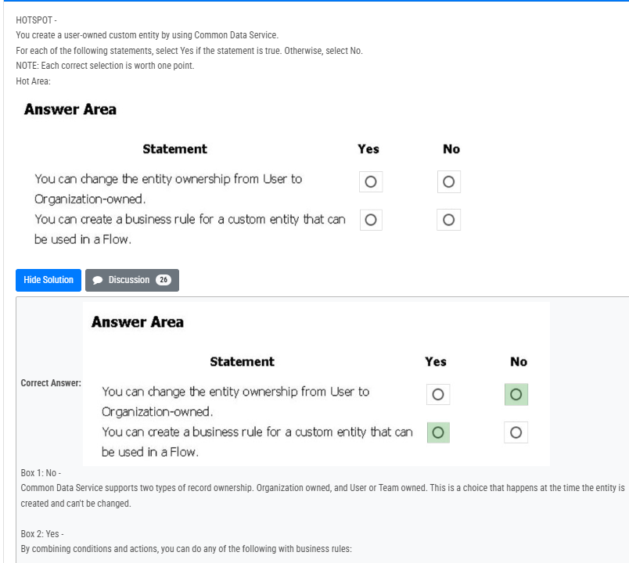

3.
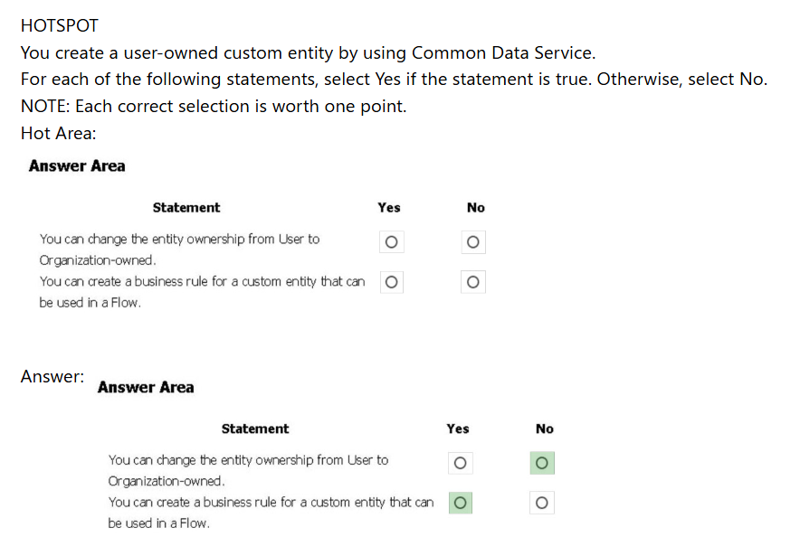

4.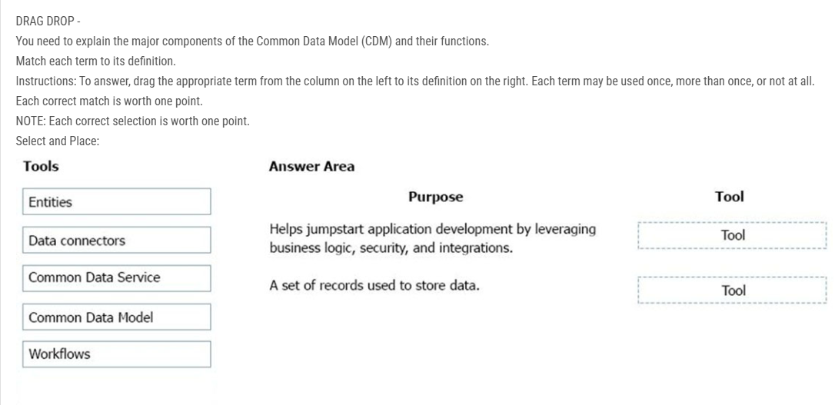
5.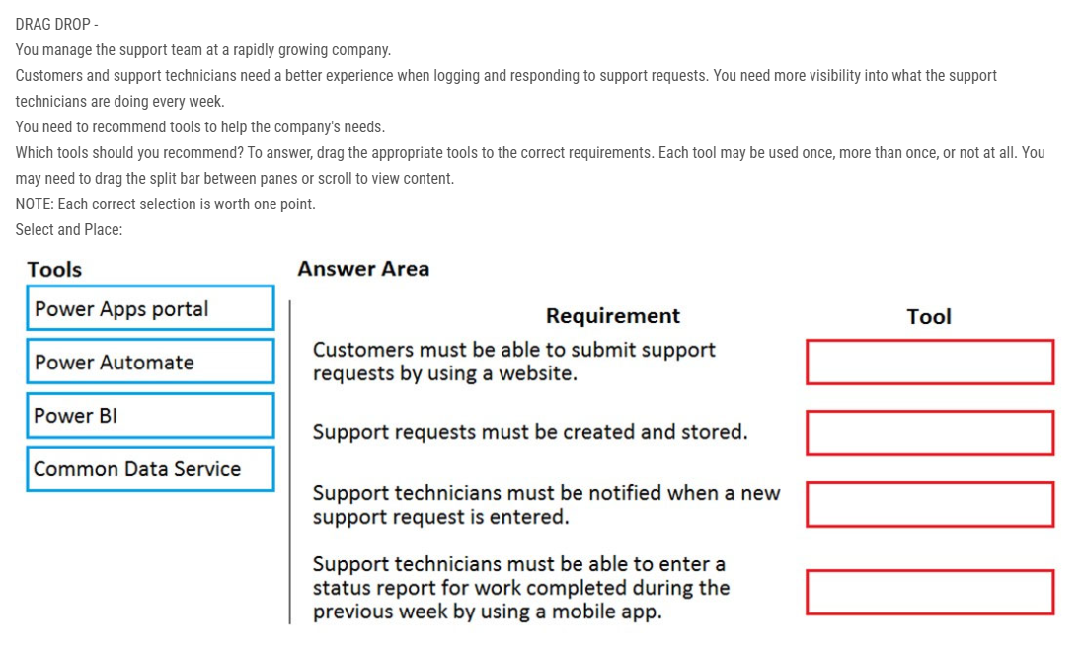
6.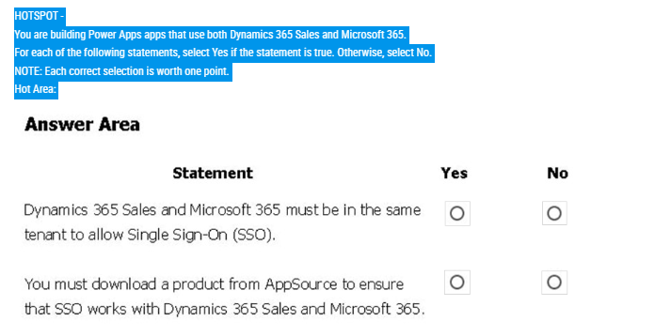
7.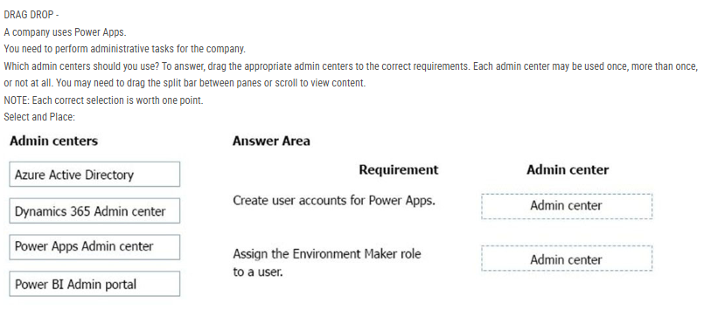
8. HOTSPOT -
A company plans to use Power Platform to build apps which address specific business challenges.
You need to recommend the appropriate types of Power Apps to use.
What should you recommend? To answer, select the appropriate option in the answer area.
NOTE: Each correct selection is worth one point.
Hot Area:
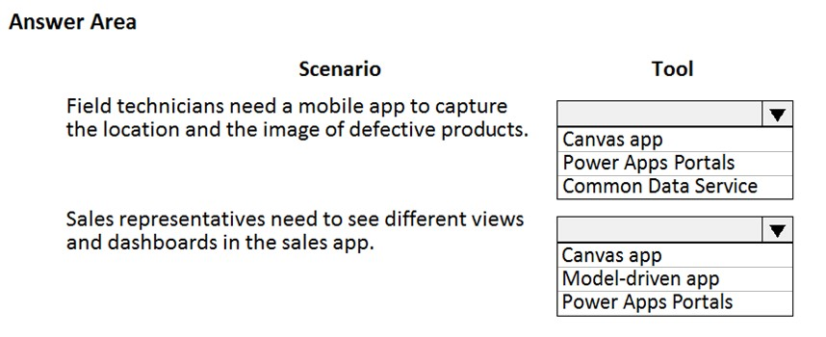

9. rapidly growing company produces Office 365 licenses for all employees. The company wants to empower users to build apps, automate business processes, and analyze data without requiring I׀¢ expertise or development skills and without increasing IT expenses and dependencies.
You need to recommend tools so that users can accomplish specific tasks.
Which tools should you recommend? To answer, select the appropriate options in the answer area.
NOTE: Each correct selection is worth one point.
Hot Area:
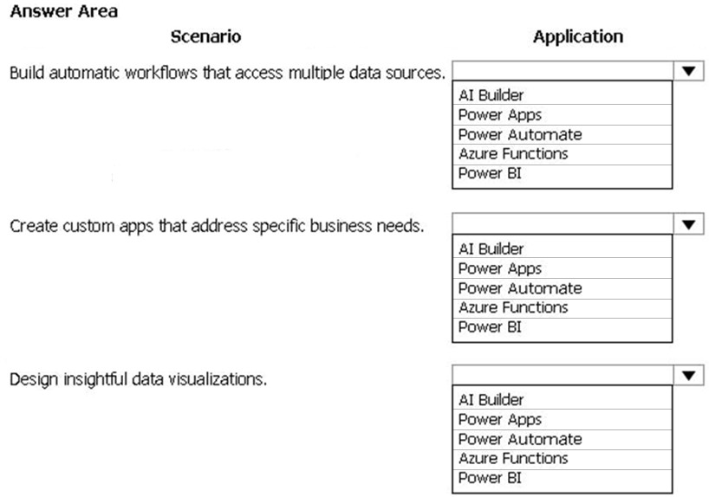
10.A company plans to use Power Platform to build apps which address specific business challenges.
You need to recommend the appropriate types of Power Apps to use.
What should you recommend? To answer, select the appropriate option in the answer area.
NOTE: Each correct selection is worth one point.
Hot Area:

Correct Answer: 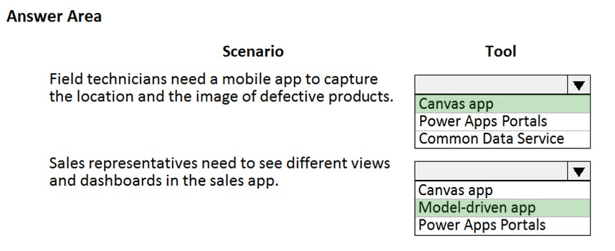
Reference:
https://docs.microsoft.com/en-us/powerapps/maker/canvas-apps/getting-started https://docs.microsoft.com/en-us/powerapps/maker/model-driven-apps/model-driven-app-overview

Question #11

A large retail company implements Power Apps, Microsoft Flow, and the Common Data Service.
The board of directors is asking whether users are finding value in the technology. The company would like to measure and report usage of the software.
You need to recommend a tool to determine software usage.
What should you recommend?
A
Microsoft Intune
B
Azure Stream Analytics
C
Power Platform Analytics
D
Dynamics 365 Product Insights
uestion Discussion19 ChatGPT
Share

Question #12

DRAG DROP -
A company uses Power Apps.
You need to perform administrative tasks for the company.
Which admin centers should you use? To answer, drag the appropriate admin centers to the correct requirements. Each admin center may be used once, more than once, or not at all. You may need to drag the split bar between panes or scroll to view content.
NOTE: Each correct selection is worth one point.
Select and Place:
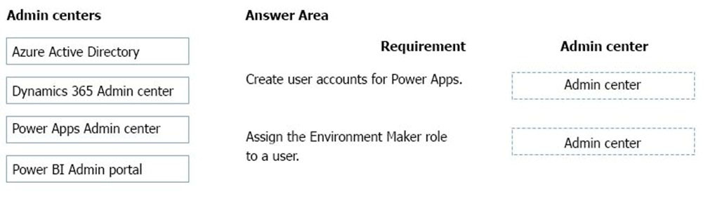
uestion Discussion15 ChatGPT
Share

Question #13

HOTSPOT -
A rapidly growing company produces Office 365 licenses for all employees. The company wants to empower users to build apps, automate business processes, and analyze data without requiring I׀¢ expertise or development skills and without increasing IT expenses and dependencies.
You need to recommend tools so that users can accomplish specific tasks.
Which tools should you recommend? To answer, select the appropriate options in the answer area.
NOTE: Each correct selection is worth one point.
Hot Area:
uestion Discussion21 ChatGPT
Share

Question #14

HOTSPOT -
A company plans to use Power Platform to build apps which address specific business challenges.
You need to recommend the appropriate types of Power Apps to use.
What should you recommend? To answer, select the appropriate option in the answer area.
NOTE: Each correct selection is worth one point.
Hot Area:

Question #15Topic 1

DRAG DROP -
A travel company plans to use the Power Platform to create tools that help travel agents book customer travel.
You need to recommend solutions for the company.
What should you recommend? To answer, drag the appropriate tools to the correct requirements. Each tool may be used once, more than once, or not at all. You may need to drag the split bar between panes or scroll to view content.
NOTE: Each correct selection is worth one point.
Select and Place:
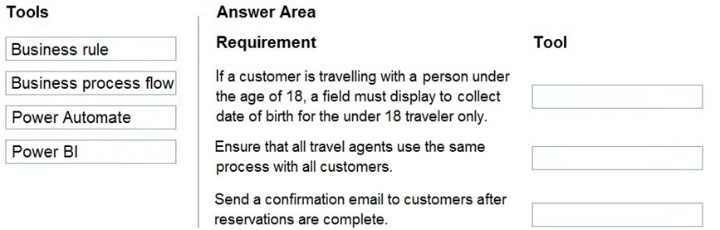

Question #16Topic 1
DRAG DROP -
A company has locations in multiple regions. The company develops solutions based on Power Apps and Power Automate.
You need to recommend features to support the implementation.
Which Power Platform features should you recommend? To answer, drag the appropriate features to the correct requirements. Each feature may be used once, more than once, or not at all. You may need to drag the split bar between panes or scroll to view content.
NOTE: Each correct selection is worth one point.
Select and Place:
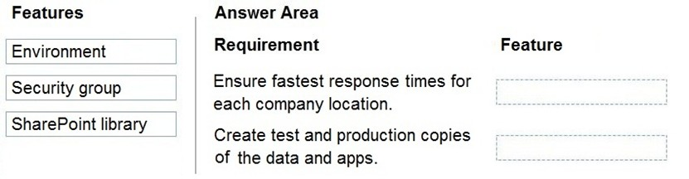

Question #17Topic 1
HOTSPOT -
You have version 1.0.0.0 of a published Power Apps app. You create and publish version 2.0.0.0 of the app. A customer goes through the process of restoring the previous version of the app.
How many versions of the app are displayed in the Version tab for the app? To answer, select the appropriate option in the answer area.
Hot Area:
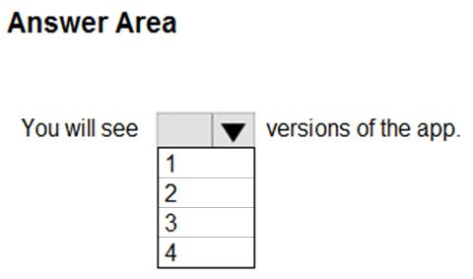

Question #18Topic 1
HOTSPOT -
A company is evaluating ways to connect Power Platform apps to external services to perform complex activities.
For each of the following statements, select Yes if the statement is true. Otherwise, select No.
NOTE: Each correct selection is worth one point.
Hot Area:
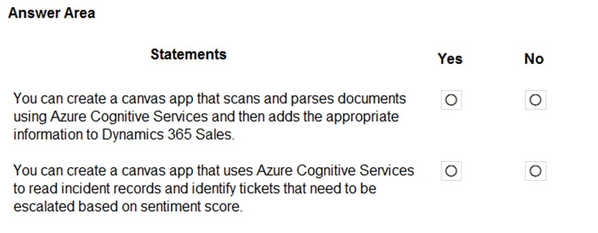

Question #19Topic 1
A company uses Power Platform.
You must ensure that users cannot share customer data with other users. You must also ensure that uses cannot connect to data sources unless you grant the user explicit permissions to access a data source.
You need to recommend solutions to meet the company's security requirements.
Which two types of policies should you recommend? Each correct answer presents part of the solution.
NOTE: Each correct selection is worth one point.
A. Office cloud policies
B. Group Policy Objects
C. environment-level policies
D. tenant-level policies
E. preset security policies

Question #20Topic 1
HOTSPOT -
An organization plans to create Power Platform solutions and is evaluating Microsoft Dataverse.
Instructions: For each of the following statements, select Yes if the statement is true. Otherwise, select No.
NOTE: Each correct selection is worth one point.
Hot Area:
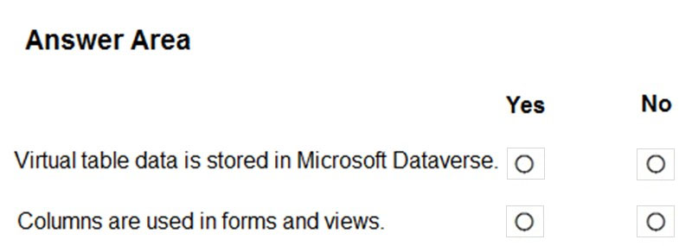

Instructions: For each of the following statements, select Yes if the statement is true. Otherwise, select No.
NOTE: Each correct selection is worth one point.
Hot Area:
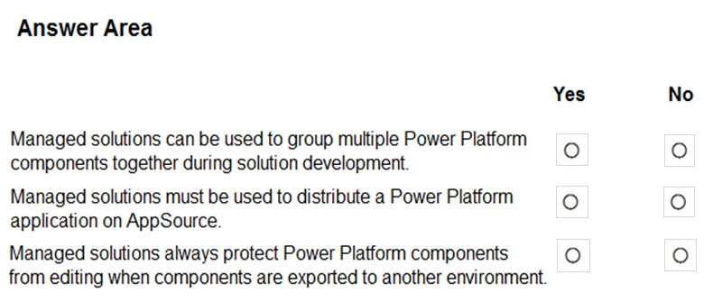
21.HOTSPOT -
A company creates the following Microsoft Power Platform environments to manage a custom model-driven app:
✑ Development
✑ Production
You have been granted the System Administrator security role to the development environment and a custom security role named Project Team Member to the production environment.
Instructions: For each of the following statements, select Yes if the statement is true. Otherwise, select No.
NOTE: Each correct selection is worth one point.
Hot Area:
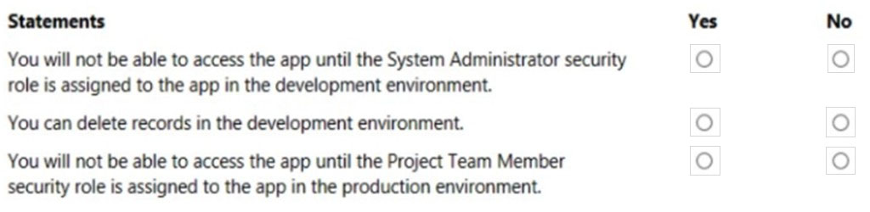
22.HOTSPOT -
Instructions: For each of the following statements, select Yes if the statement is true. Otherwise, select No.
NOTE: Each correct selection is worth one point.
Hot Area:

Correct Answer:
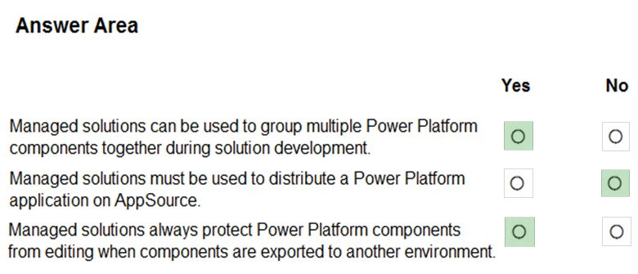
Box 1: Yes -
Managed solutions are used to deploy to any environment that isn't a development environment for that solution.
Box 2: No -
Unmanaged solutions can be exported either as unmanaged or managed.
Box 3: Yes -
You can't edit components directly within a managed solution. To edit managed components, first add them to an unmanaged solution.
Reference:
https://docs.microsoft.com/en-us/power-platform/alm/solution-concepts-alm

uestion Discussion18 ChatGPT
Share

Question #22

DRAG DROP -
A team of five people plans to create Power Platform solutions for a company. Team members plan to initially use Power Platform trial instances to create solutions.
Team members have questions about how many Power Platform instances and Common Data Service databases they need.
You need to respond to the team.
How should you respond? To answer, drag the appropriate responses to the correct questions. Each response may be used once, more than once, or not at all.
You may need to drag the split bar between panes or scroll to view content.
NOTE: Each correct selection is worth one point.
Select and Place:
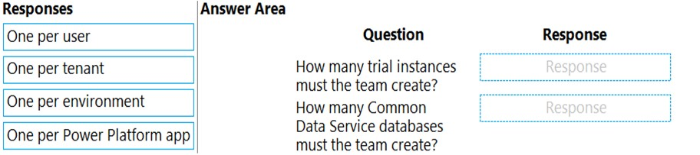

Correct Answer:
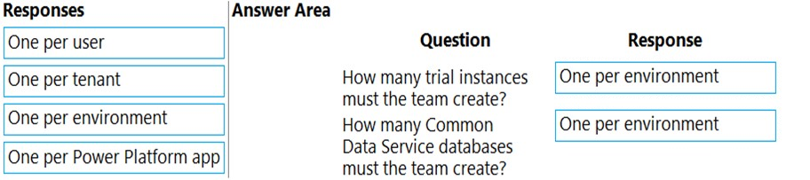

uestion Discussion15 ChatGPT Statistics
Share

Question #23

A company is creating a canvas app to track and analyze customer visits to their retail stores. Data about customer visits is stored on-premises at each retail store location.
The app must display data about customer visits when users launch the app.
You need to ensure that the data is available for consumption by the app.
Which tool should you use?
A
Connector
B
Microsoft Dataverse
C
Data source
D
Power Automate
E
Data gateway
uestion Discussion20 ChatGPT
Share

Question #24

HOTSPOT -
For each of the following statements, select Yes if the statement is true. Otherwise, select No.
NOTE: Each correct selection is worth one point.
Hot Area:
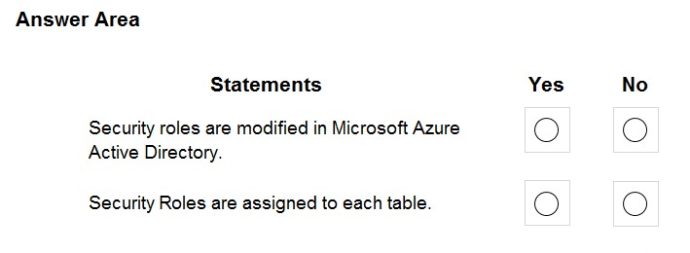

Correct Answer:
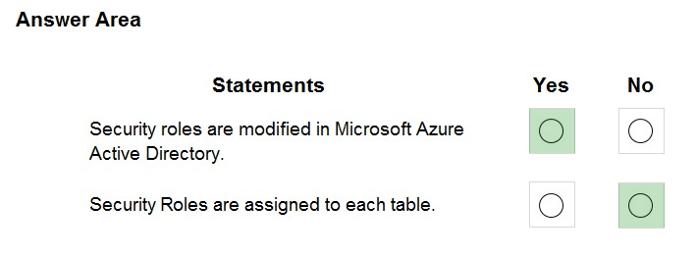
Box 1: Yes -
You can't modify the built-in security roles, other than add administrative users. You can copy the role, make changes, and then save these changes as a new custom security role.
Note: A security role defines how different users, such as salespeople, access different types of records. To control access to data, you can modify existing security roles, create new security roles, or change which security roles are assigned to each user.
Box 2: No -
Security roles are assigned to users and to groups, not to tables.
Reference:
https://docs.microsoft.com/en-us/mem/configmgr/core/understand/fundamentals-of-role-based-administration#security-roles

uestion Discussion12 ChatGPT Statistics
Share

Question #25

A company currently does not separate testing, development and production as per standard Application Lifecycle Management (ALM) protocol. The company uses Power Apps for accounting and sales processes.
The company needs to use only one login account per user. The company also must prevent development and testing from impacting production.
You need to implement a solution to meet the requirements.
Which method should you select?
A
separate environments
Most Voted
B
separate tenants
C
separate Microsoft Azure Storage Blobs
D
separate connectors

Correct Answer:
A
To follow application lifecycle management (ALM) principles, you'll need separate environments for app development and production. Although you can perform basic ALM with only separate development and production environments, we recommend that you also maintain at least one test environment that's separate from your development and production environments.
Reference:
https://docs.microsoft.com/en-us/power-platform/alm/environment-strategy-alm

uestion Discussion23 ChatGPT
Share

Question #26

HOTSPOT -
A company creates the following Microsoft Power Platform environments to manage a custom model-driven app:
✑ Development
✑ Production
You have been granted the System Administrator security role to the development environment and a custom security role named Project Team Member to the production environment.
Instructions: For each of the following statements, select Yes if the statement is true. Otherwise, select No.
NOTE: Each correct selection is worth one point.
Hot Area:

Correct Answer:
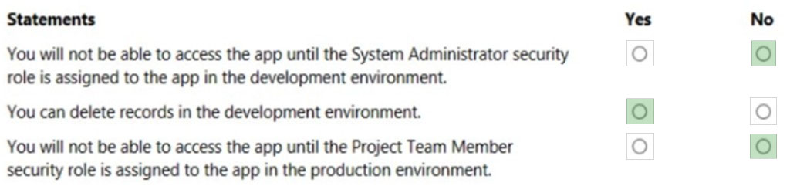
Box 1: No -
You already have this access as a System Administrator.
Users who have the Environment Maker, System Administrator, or System Customizer security role can access and edit all model-driven apps within the environment. This is because these security roles have create, read, and write privileges on the Model-driven App table.
Box 2: Yes -
If you are the System Administrator role in your CDS (Common Data Service), you would have full permission to customize or administer the environment, including creating, modifying, and assigning security roles.
Currently, within PowerApps, there is no way to prevent CDS System Administrator role from deleting a record in an Entity.
Box 3: No -
Other security options are available.
Also, there is no information on what the custom Project Team Member role entails.
Note: Apps can be viewed by valid users with appropriate privileges who sign into Power Apps, the Power Apps mobile app, or Dynamics 365 home page. For a user to view and access apps in an environment, the following privileges, security role, or team membership are required:
A user who has the write or create privilege on the Model-driven App table makes the user a maker persona. That user can view and access all apps in the environment.
A user who has only the read privilege on the Model-driven App table, must also have the associated security role(s) that are assigned to the app (or equivalent).
Reference:
https://docs.microsoft.com/en-us/power-apps/maker/model-driven-apps/app-visibility-privileges https://docs.microsoft.com/en-us/power-platform/admin/database-security

uestion Discussion9 ChatGPT
Share

Question #27

DRAG DROP -
A company uses Dynamics 365 Sales.
You have the following requirements:
* View analytics on accounts.
* The model-driven app must automatically send an approval form to a manager when the purchase price is greater than $10,000.
* Create a chatbot for the webpage to interact with customer questions.
You must use Microsoft Power Platform to extend the capabilities of Dynamics 365 Sales.
You need to select an application for each requirement.
Which application should you use? To answer, drag the appropriate application to the correct requirement. Each application may be used once, more than once, or not at all. You may need to drag the split bar between panes or scroll to view content.
NOTE: Each correct selection is worth one point.
Select and Place:
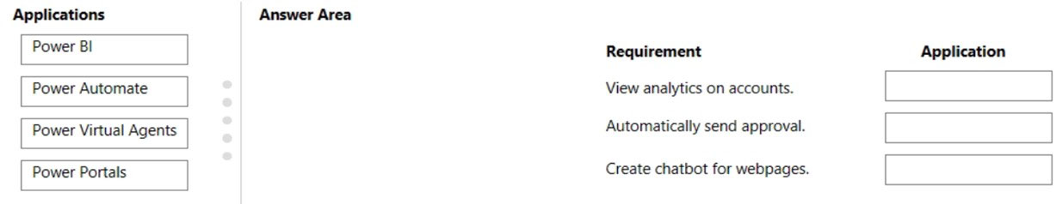

Correct Answer:
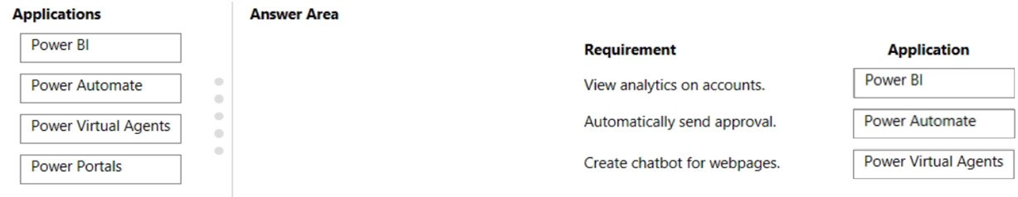
Box 1: Power BI -
You can configure Customer Service Analytics dashboards in Power BI.
Box 2: Power Automate -
Power Automate, Trigger a cloud flow based on email properties.
Use the When a new email arrives (V3) trigger to create a cloud flow that runs when one or more of the following email properties match criteria that you provide.
Box 3: Power Virtual Agents -
Power Virtual Agents lets you create powerful AI-powered chatbots for a range of requestsג€"from providing simple answers to common questions to resolving issues requiring complex conversations.
Reference:
https://docs.microsoft.com/en-us/dynamics365/customer-service/configure-customer-service-analytics-dashboard https://docs.microsoft.com/en-us/power-virtual-agents/fundamentals-what-is-power-virtual-agents https://docs.microsoft.com/en-us/power-automate/email-triggers

uestion Discussion24 ChatGPT
Share

Question #28

HOTSPOT -
A company plans to use Power BI to visualize data from business systems.
For each of the following statements, select Yes if the statement is true. Otherwise, select No.
NOTE: Each correct selection is worth one point.
Hot Area:
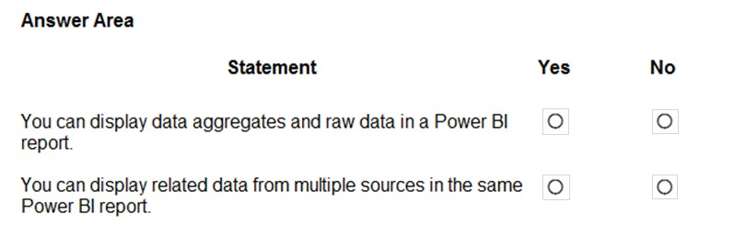

Correct Answer:
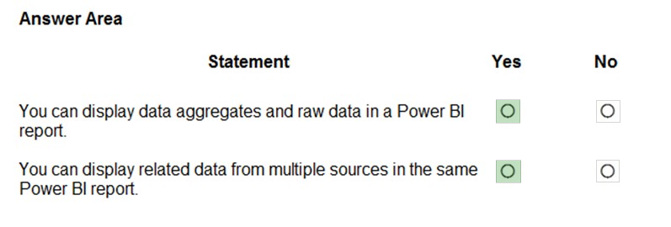
Box 1: Yes -
The following list provides advantages to using aggregations:
Query performance over big data - as users interact with visuals on Power BI reports, DAX queries are submitted to the dataset. Boost query speeds by caching data at the aggregated level, using a fraction of the resources required at the detail level. Unlock big data in a way that would otherwise be impossible.
Box 2: Yes -
With Power BI Desktop, you can connect to many different types of data sources, then shape the data to meet your needs, enabling you to create visual reports to share with others. Shaping data means transforming the data: renaming columns or tables, changing text to numbers, removing rows, setting the first row as headers, and so on. Combining data means connecting to two or more data sources, shaping them as needed, then consolidating them into a useful query.
Reference:
https://docs.microsoft.com/en-us/power-bi/desktop-aggregations https://docs.microsoft.com/en-us/power-bi/connect-data/desktop-shape-and-combine-data

uestion Discussion15 ChatGPT Statistics
Share

Question #29

A company is evaluating ways that they can implement AI Builder.
For which two scenarios can you use AI Builder? Each correct answer presents a complete solution.
NOTE: Each correct selection is worth one point.
A
Send emails to all users who subscribe to a service.
B
Synchronize data from an external database.
C
Collect data from several data sources and display a dashboard that shows trending data.
D
Interpret images and perform an action based on the image.
Most Voted
E
Detect patterns in data and predict outcomes.
Most Voted

Correct Answer:
DE
Reference:
https://powerapps.microsoft.com/en-us/blog/introducing-ai-builder-for-powerplatform/

uestion Discussion19 ChatGPT
Share

Question #30

HOTSPOT -
A company plans to create Power Platform apps that consume industry-standard and proprietary data sources.
For each of the following statements, select Yes if the statement is true. Otherwise, select No.
NOTE: Each correct selection is worth one point.
Hot Area:
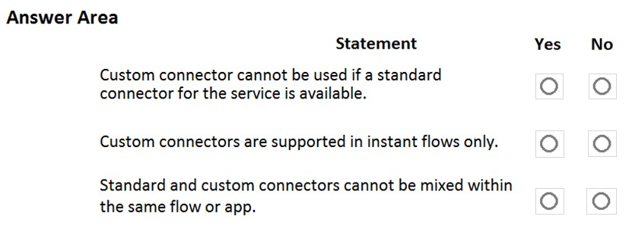

Correct Answer:
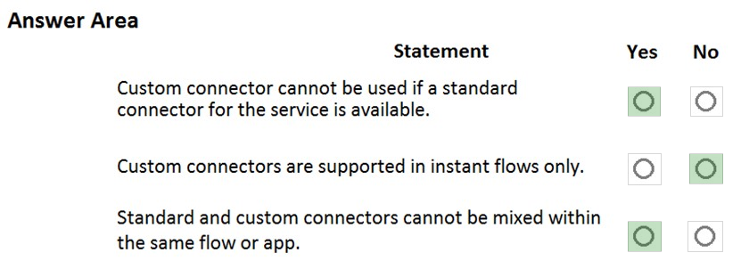
Reference:
https://docs.microsoft.com/en-us/powerapps/maker/canvas-apps/connections-list

Question #31

HOTSPOT -
A company is evaluating Power Platform and has questions about the role that Microsoft Dataverse plays in using Power Apps and Power Automate.
For each of the following statements, select Yes if the statement is true. Otherwise, select No.
NOTE: Each correct selection is worth one point.
Hot Area:
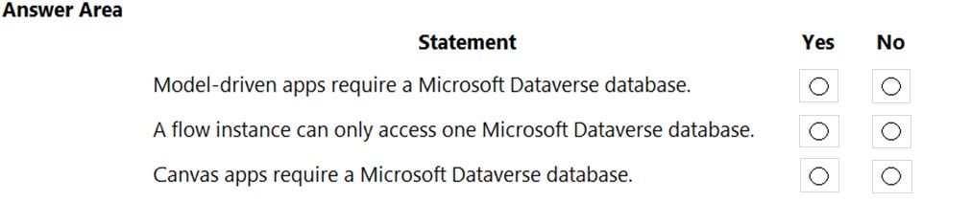
uestion Discussion20 ChatGPT
Share

Question #32

HOTSPOT -
A company plans to create a Common Data Service environment.
For each of the following statements, select Yes if the statement is true. Otherwise, select No.
NOTE: Each correct selection is worth one point.
Hot Area:
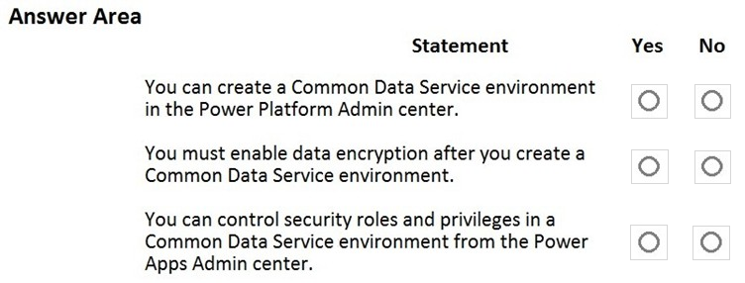
uestion Discussion15 ChatGPT Statistics
Share

Question #33

A company plans to use AI Builder to help improve business performance.
You need to determine which AI Models are available for use.
Which three types of models can you use? Each correct answer presents a complete solution.
NOTE: Each correct selection is worth one point.
A
linear regression
B
prediction
C
object detection
D
anomaly detection
E
text classification
uestion Discussion19 ChatGPT Statistics
Share

Question #34

A company uses Microsoft 365 and Dynamics 365 Sales. The company does not have any developers on its staff.
You need to explain to the executives the benefits of using Power Platform apps.
What are two benefits? Each correct answer presents a complete solution.
NOTE: Each correct selection is worth one point.
A
Users can send emails from Dynamics 365 Sales to their personal email addresses.
B
Users can create Power Apps to create apps for different departments.
C
Users can use Power Automate to share information between Microsoft 365 and Dynamics 365 Sales.
D
The company can unify all the mobile devices to one vendor.
uestion Discussion13 ChatGPT
Share

Question #35

HOTSPOT -
A company needs to create several workflows and applications to help streamline their sales operations.
You need to determine which applications are appropriate for given scenarios.
Which applications should you use? To answer, select the appropriate options in the answer area.
NOTE: Each correct selection is worth one point.
Hot Area:
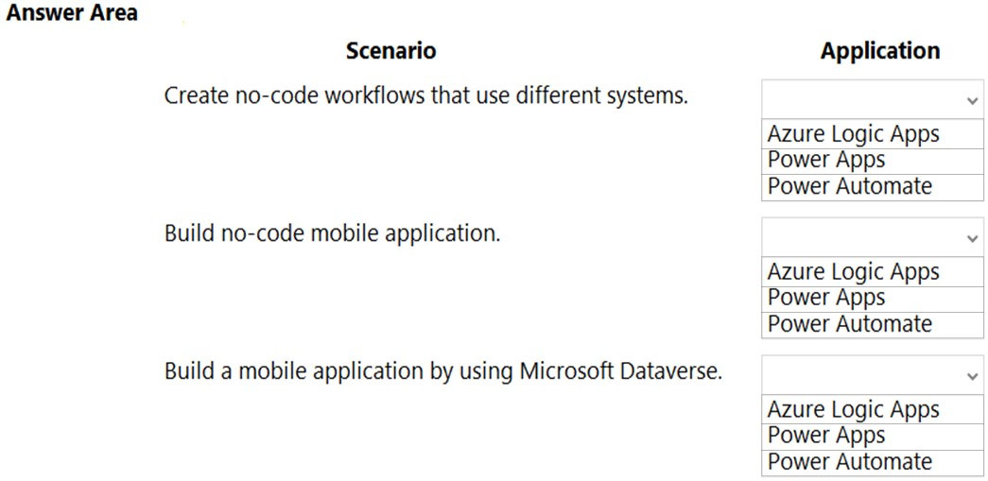
uestion Discussion16 ChatGPT Statistics
Share

Question #36

A company uses Dynamics 365 Supply Chain Management and Dynamics 365 Finance.
User account data must be synchronized between the two systems.
You need to ensure that the synchronized data is stored in one place.
What should you use?
A
Azure IoT Central
B
Azure Active Directory
C
SQL Server
D
Microsoft Dataverse
uestion Discussion19 ChatGPT Statistics
Share

Question #37

What is a benefit of deploying Microsoft 365 and Dynamics 365 apps in the same tenant?
A
Use Common Data Services to connect to application data.
B
You only need to set up groups in Microsoft 365 for permissions to all data.
C
Users can access both Microsoft 365 and Dynamics 365 by using Single Sign-on (SSO).
uestion Discussion27 ChatGPT
Share

Question #38

HOTSPOT -
You are creating a Power Apps app. You want to ensure that the app can be used by individuals who have a vision impairment.
For each of the following statements, select Yes if the statement is true. Otherwise, select No.
NOTE: Each correct selection is worth one point.
Hot Area:
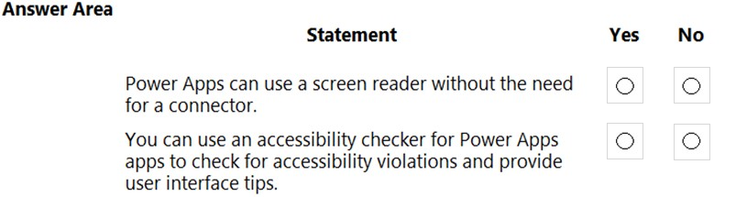
uestion Discussion11 ChatGPT
Share

Question #39

DRAG DROP -
A bank uses Power Platform apps and flows to support business processes.
The company would like to use historical client data to predict whether a client's loan application is likely to be approved or rejected.
You need to use AI Builder to implement the solution.
Which four actions should you perform in sequence? To answer, move the appropriate actions from the list of actions to the answer area and arrange them in the correct order.
Select and Place:
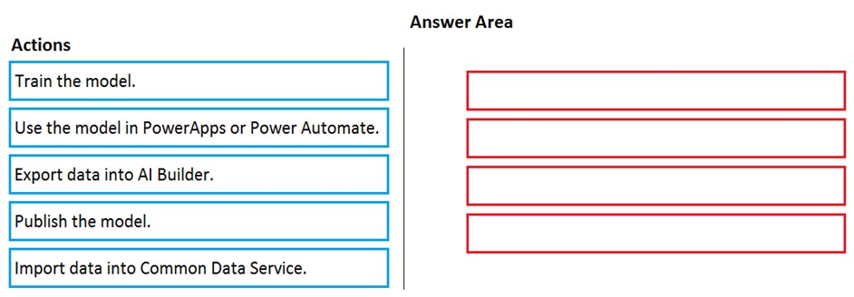
uestion Discussion14 ChatGPT
Share

Question #40

DRAG DROP -
A company plans to implement solutions that use Microsoft Dataverse.
You need to recommend features to meet the company's needs.
Which features should you recommend? To answer, drag the appropriate features to the correct requirements. Each feature may be used once, more than once, or not at all. You may need to drag the split bar between panes or scroll to view content.
NOTE: Each correct selection is worth one point.
Select and Place:
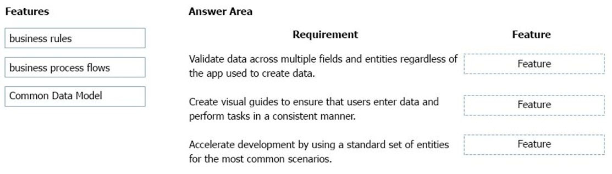

Question #51

HOTSPOT -
Your company wants to create a help desk system and implement Dynamics 365 Customer Service.
The company has the following requirements:
✑ Provide an application to allow support team staff to chat live with a customer.
✑ Automatically import data from a Microsoft Excel spreadsheet once a day.
✑ Provide a chatbot that can assist customers who need support.
You need to determine which applications to use to meet the requirements.
Which applications should you use? To answer, select the appropriate options in the answer area.
NOTE: Each correct selection is worth one point.
Hot Area:
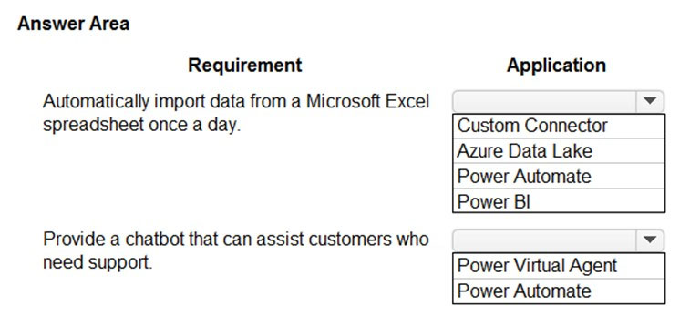
uestion Discussion22 ChatGPT Statistics
Share

Question #52

You create a business rule on contact entity to enforce the requirement that users must enter either a telephone number, fax number, or an email when creating a new record.
The company decides to remove fax number from the condition.
You need to update the business rule.
What are two ways of achieving the goal? Each correct answer presents a complete solution.
NOTE: Each correct selection is worth one point.
A
Save a copy of the rule and change the condition. Deactivate and delete the original rule.
B
Deactivate the business rule and change the condition.
C
Take a snapshot of the business rule and change the condition.
D
Change the condition and activate the change.
uestion Discussion20 ChatGPT
Share

Question #53

HOTSPOT -
You are learning about Power Apps and how to use triggers.
Which objects should you use? To answer, select the appropriate options in the answer area.
NOTE: Each correct selection is worth one point.
Hot Area:
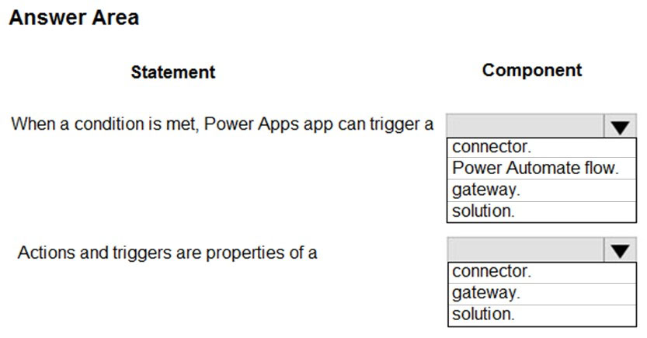
uestion Discussion18 ChatGPT Statistics
Share

Question #54

A coworker is creating an app in Power Apps and needs to automatically synchronize data from an external source. The coworker is unable to locate a suitable
Microsoft approved connector template in AppSource.
You need to recommend a solution for the coworker.
What should you recommend?
A
Create a custom connector.
B
Ask the outside source to send you the data once a week.
C
Use Power Automate to connect to the database.
D
Open a ticket with Microsoft and request a new connector.
E
Use Microsoft Azure Service Bus.
uestion Discussion18 ChatGPT Statistics
Share

Question #55

A toy company creates a text classification model in AI Builder to monitor customer feedback for specific key words.
When negative feedback is received for a toy, the company wants to proactively perform engineering reviews for the toy and schedule additional training sessions for workers who produce the toy.
What are two possible ways to achieve the goal? Each correct answer presents a complete solution.
NOTE: Each correct selection is worth one point.
A
Create a canvas app.
B
Implement the Virtual Agent.
C
Build a Power Automate flow.
D
Use the Common Data Model.
uestion Discussion3 ChatGPT
Share

Question #56

HOTSPOT -
A company is evaluating AI Builder.
Instructions: For each of the following statements, select Yes if the statement is true. Otherwise, select No.
NOTE: Each correct selection is worth one point.
Hot Area:
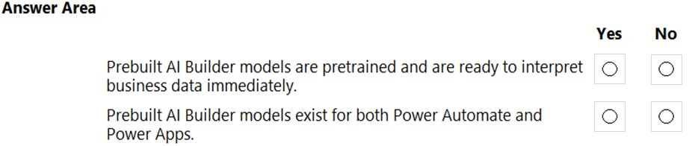
uestion Discussion22 ChatGPT
Share

Question #57

DRAG DROP -
You are implementing a solution for an animal hospital.
The animal hospital must contact owners regarding their pets.
You need to model the owner and pet object information by using Microsoft Dataverse. The solution must minimize the amount of customization required:
✑ owner first name
✑ owner last name
✑ owner email address
✑ owner date of birth
✑ pet name
pet breed
✑ pet owner
Which component should you use? To answer, drag the appropriate components to the correct data. Each component may be used once, more than once, or not at all. You may need to drag the split bar between panes or scroll to view content.
NOTE: Each correct selection is worth one point.
Select and Place:
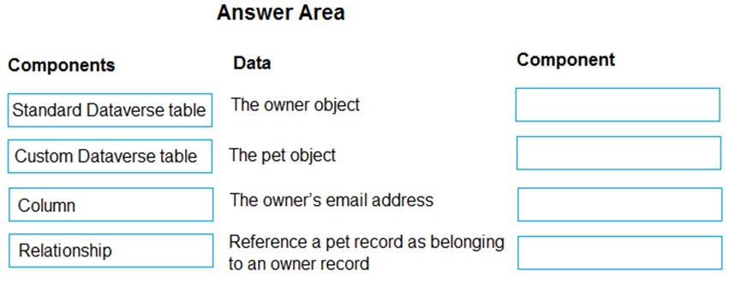
uestion Discussion9 ChatGPT
Share

Question #58

DRAG DROP -
A company plans to build canvas apps that will be used within Microsoft Teams.
You need to identify the platform based on the design considerations.
To answer, drag the appropriate platforms to the correct design considerations. Each platform may be used once, more than once, or not at all. You may need to drag the split bar between panes or scroll to view content.
NOTE: Each correct selection is worth one point.
Select and Place:
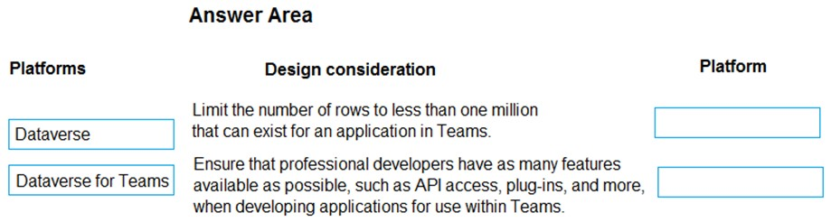
uestion Discussion20 ChatGPT Statistics
Share

Question #59

You need to display sales orders greater than a specific threshold in a Power BI report.
What should you use?
A
filter
B
Power Query
C
Common Data Service
D
connector
uestion Discussion30 ChatGPT Statistics
Share

Question #60

You are a sales representative. You create a Power BI report to visualize data from a Microsoft Excel workbook.
Users need to be able to view and share the report.
Which two actions should you perform? Each correct answer presents part of the solution.
NOTE: Each correct selection is worth one point.
A
Pin the report to a dashboard.
B
Export the data.
C
Publish the dashboard.
D
Share the dashboard.

Question #41

DRAG DROP -
A manufacturing company is evaluating AI Builder.
You need to select AI Builder models to address specified requirements.
Which model types should you use? To answer, drag the appropriate model types to the correct requirements. Each model type may be used once, more than once, or not at all. You may need to drag the split bar between panes or scroll to view content.
NOTE: Each correct selection is worth one point.
Select and Place:
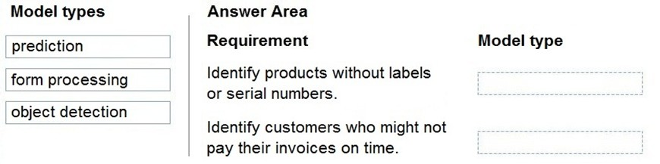
uestion Discussion6 ChatGPT
Share

Question #42

DRAG DROP -
You manage the support team at a rapidly growing company.
Support technicians need a better experience when logging and responding to support requests.
You need to recommend tools to help the company's needs.
Which tools should you recommend? To answer, drag the appropriate tools to the correct requirements. Each tool may be used once, more than once, or not at all. You may need to drag the split bar between panes or scroll to view content.
NOTE: Each correct selection is worth one point.
Select and Place:
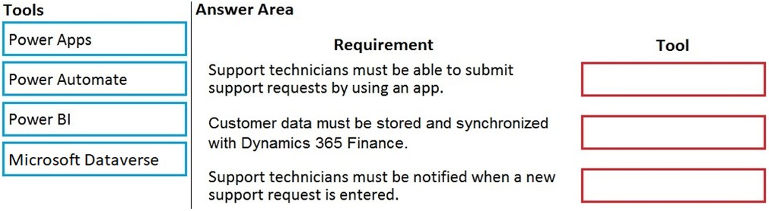
uestion Discussion20 ChatGPT
Share

Question #43

HOTSPOT -
A business is evaluating AI Builder.
Which actions can you perform?
For each of the following statements, select Yes if the statement is true. Otherwise, select No.
NOTE: Each correct selection is worth one point.
Hot Area:
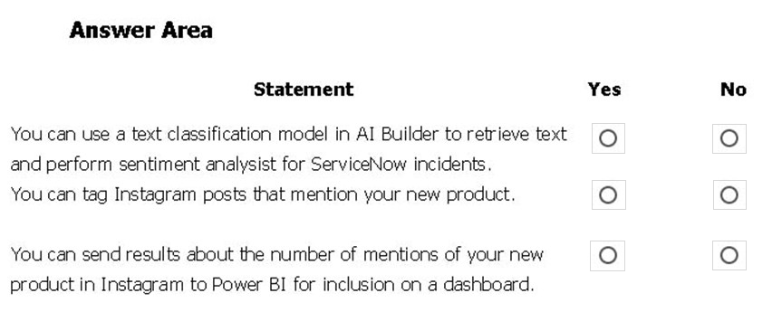
uestion Discussion26 ChatGPT
Share

Question #44

DRAG DROP -
Match each tool to its task. To answer, drag the appropriate tool from the column on the left to its task on the right. Each tool may be used once, more than once, or not at all.
NOTE: Each correct match is worth one point.
Select and Place:
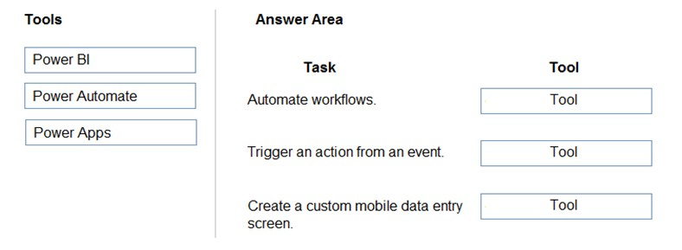
uestion Discussion20 ChatGPT
Share

Question #45

HOTSPOT -
You are a retail director for a large clothing company. Each week you use the corporate YouTube channel to create a video that highlights new initiatives, and goals for retail operations.
You need to design a Power Apps app that streams the videos to internal users.
Which objects should you use? To answer, select the appropriate options in the answer area.
NOTE: Each correct selection is worth one point.
Hot Area:
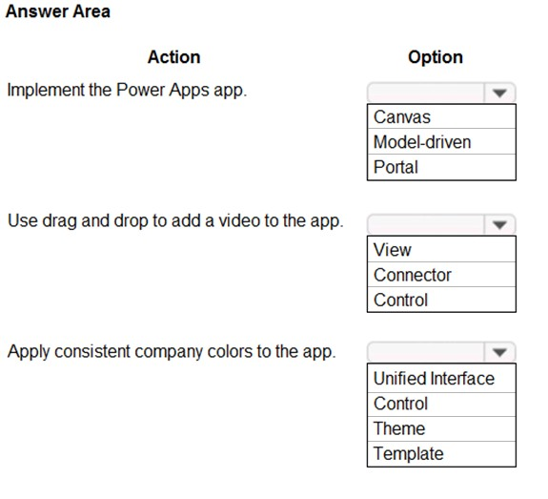
uestion Discussion19 ChatGPT
Share

Question #46

HOTSPOT -
You want to create a Power Apps app that allows you to define a custom Sitemap.
What should you do? To answer, select the appropriate options in the answer area.
Hot Area:
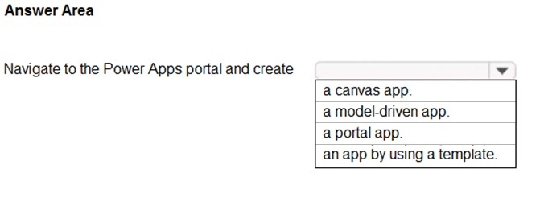
uestion Discussion32 ChatGPT Statistics
Share

Question #47

A company is building apps to support their business operations. The apps will use connectors to access data from several data sources and respond to a number of events generated by components.
Which two operations can you use for connectors? Each correct answer presents part of the solution.
NOTE: Each correct selection is worth one point.
A
Actions
B
Plug-ins
C
Gateways
D
Triggers
uestion Discussion11 ChatGPT Statistics
Share

Question #48

You are a sales manager for a large retail organization.
You are creating a Power Apps app that will display customer product purchase information from your old point-of-sale (POS) system and need to link those sales to the customer accounts and product sales in Dynamics 365 Commerce.
You need to use the appropriate component.
What should you use?
A
Microsoft Dataverse
B
business process flow
C
entity metadata
D
business rule
Question Discussion19 ChatGPT Statistics
Share

Question #49

You create a Power Virtual Agents chatbot.
You need to share the bot with other team members so that they can try out the bot before you share the bot with customers.
What should you use?
A
demo website
B
live production website
C
test chat feature
uestion Discussion27 ChatGPT
Share

Question #50

HOTSPOT -
You are planning to use the Business Card Reader and Sentiment Analysis prebuilt AI models to build solutions.
For each of the following statements, select Yes if the statement is true. Otherwise, select No.
NOTE: Each correct selection is worth one point.
Hot Area:
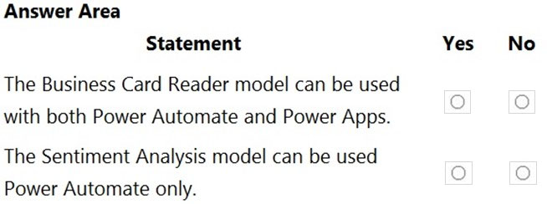

Question #51

HOTSPOT -
Your company wants to create a help desk system and implement Dynamics 365 Customer Service.
The company has the following requirements:
✑ Provide an application to allow support team staff to chat live with a customer.
✑ Automatically import data from a Microsoft Excel spreadsheet once a day.
✑ Provide a chatbot that can assist customers who need support.
You need to determine which applications to use to meet the requirements.
Which applications should you use? To answer, select the appropriate options in the answer area.
NOTE: Each correct selection is worth one point.
Hot Area:
uestion Discussion22 ChatGPT Statistics
Share

Question #52

You create a business rule on contact entity to enforce the requirement that users must enter either a telephone number, fax number, or an email when creating a new record.
The company decides to remove fax number from the condition.
You need to update the business rule.
What are two ways of achieving the goal? Each correct answer presents a complete solution.
NOTE: Each correct selection is worth one point.
A
Save a copy of the rule and change the condition. Deactivate and delete the original rule.
B
Deactivate the business rule and change the condition.
C
Take a snapshot of the business rule and change the condition.
D
Change the condition and activate the change.
uestion Discussion20 ChatGPT
Share

Question #53

HOTSPOT -
You are learning about Power Apps and how to use triggers.
Which objects should you use? To answer, select the appropriate options in the answer area.
NOTE: Each correct selection is worth one point.
Hot Area:
uestion Discussion18 ChatGPT Statistics
Share

Question #54

A coworker is creating an app in Power Apps and needs to automatically synchronize data from an external source. The coworker is unable to locate a suitable
Microsoft approved connector template in AppSource.
You need to recommend a solution for the coworker.
What should you recommend?
A
Create a custom connector.
B
Ask the outside source to send you the data once a week.
C
Use Power Automate to connect to the database.
D
Open a ticket with Microsoft and request a new connector.
E
Use Microsoft Azure Service Bus.
uestion Discussion18 ChatGPT Statistics
Share

Question #55

A toy company creates a text classification model in AI Builder to monitor customer feedback for specific key words.
When negative feedback is received for a toy, the company wants to proactively perform engineering reviews for the toy and schedule additional training sessions for workers who produce the toy.
What are two possible ways to achieve the goal? Each correct answer presents a complete solution.
NOTE: Each correct selection is worth one point.
A
Create a canvas app.
B
Implement the Virtual Agent.
C
Build a Power Automate flow.
D
Use the Common Data Model.
uestion Discussion3 ChatGPT
Share

Question #56

HOTSPOT -
A company is evaluating AI Builder.
Instructions: For each of the following statements, select Yes if the statement is true. Otherwise, select No.
NOTE: Each correct selection is worth one point.
Hot Area:
uestion Discussion22 ChatGPT
Share

Question #57

DRAG DROP -
You are implementing a solution for an animal hospital.
The animal hospital must contact owners regarding their pets.
You need to model the owner and pet object information by using Microsoft Dataverse. The solution must minimize the amount of customization required:
✑ owner first name
✑ owner last name
✑ owner email address
✑ owner date of birth
✑ pet name
pet breed
✑ pet owner
Which component should you use? To answer, drag the appropriate components to the correct data. Each component may be used once, more than once, or not at all. You may need to drag the split bar between panes or scroll to view content.
NOTE: Each correct selection is worth one point.
Select and Place:
uestion Discussion9 ChatGPT
Share

Question #58

DRAG DROP -
A company plans to build canvas apps that will be used within Microsoft Teams.
You need to identify the platform based on the design considerations.
To answer, drag the appropriate platforms to the correct design considerations. Each platform may be used once, more than once, or not at all. You may need to drag the split bar between panes or scroll to view content.
NOTE: Each correct selection is worth one point.
Select and Place:
uestion Discussion20 ChatGPT Statistics
Share

Question #59

You need to display sales orders greater than a specific threshold in a Power BI report.
What should you use?
A
filter
B
Power Query
C
Common Data Service
D
connector
uestion Discussion30 ChatGPT Statistics
Share

Question #60

You are a sales representative. You create a Power BI report to visualize data from a Microsoft Excel workbook.
Users need to be able to view and share the report.
Which two actions should you perform? Each correct answer presents part of the solution.
NOTE: Each correct selection is worth one point.
A
Pin the report to a dashboard.
B
Export the data.
C
Publish the dashboard.
D
Share the dashboard.

Question #61

HOTSPOT -
You create reports within Power BI to report on the status of a project. A manager asks you to share the reports with other team members. You decide to create a published app and set permissions to allow other team members to view the reports.
For each of the following statements, select Yes if the statement is true. Otherwise, select No.
NOTE: Each correct selection is worth one point.
Hot Area:
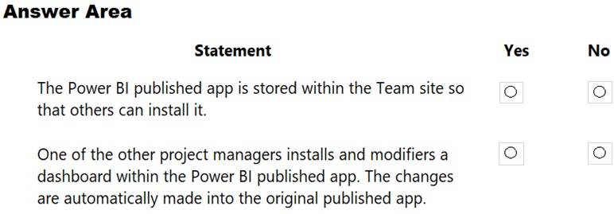
uestion Discussion22 ChatGPT
Share

Question #62

DRAG DROP -
A company plans to create an information portal that managers can use to view critical information about their teams.
You need to recommend the type of Power BI components that the company should use.
What should you recommend? To answer, drag the appropriate component types to the correct requirements. Each component type may be used once, more than once, or not at all. You may need to drag the split bar between panes or scroll to view content.
NOTE. Each correct selection is worth one point.
Select and Place:
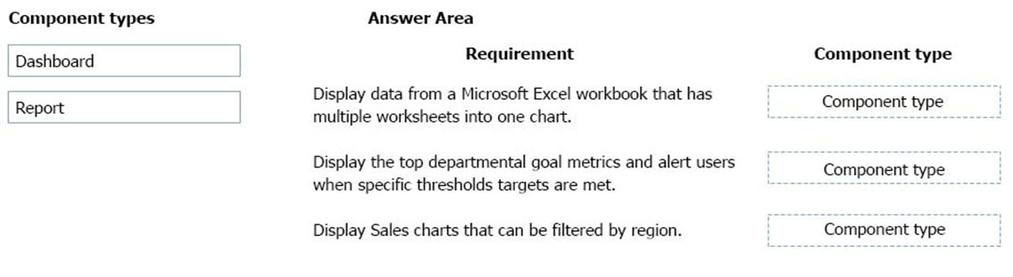
uestion Discussion23 ChatGPT
Share

Question #63

HOTSPOT -
You have a Power BI report.
For each of the following statements, select Yes if the statement is true. Otherwise, select No.
NOTE: Each correct selection is worth one point.
Hot Area:
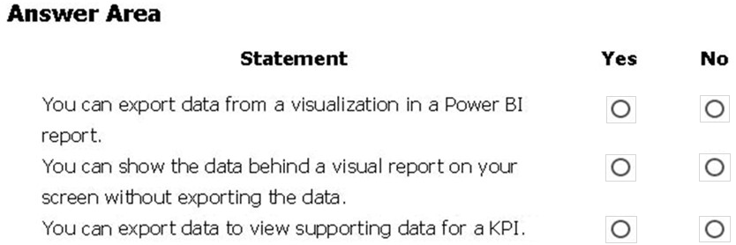
uestion Discussion20 ChatGPT Statistics
Share

Question #64

You create a Power BI dashboard that displays data from Dynamics 365 Customer Engagement.
You need to share the Power BI dashboard with coworkers.
What are three possible ways to achieve the goal? Each correct answer presents a complete solution.
NOTE: Each correct selection is worth one point.
A
Create a Power BI workspace and grant coworkers permissions.
B
Publish the dashboard as an app to your coworkers.
C
Export the data into Common Data Service for others to manipulate in Power BI.
D
Export the data to Microsoft Excel for coworkers to import and view in Power BI.
E
Embed reports in your company's internal web portal.
uestion Discussion10 ChatGPT Statistics
Share

Question #65

Your company has an on-premises Microsoft SQL Server database that contains legacy sales data. You must display information from the database in a new
Power Apps app.
You need to establish a secure connection between the database and the app.
What should you use?
A
Data source
B
App
C
Data gateway
D
Power Automate
uestion Discussion15 ChatGPT Statistics
Share

Question #66

A recent update has been made to a canvas app.
The update causes usability issues.
You need to roll back the app to a previous version.
What should you do?
A
Restore the previous version of the app.
B
Uninstall the app for all users and reinstall by using the package from a previous version.
C
Deactivate the live app, import the previous version of the app, and then activate the app.
D
Delete the app and create a new app based on the previous version.
uestion Discussion24 ChatGPT Statistics
Share

Question #67

You are a district manager for a large retail organization. You train each store manager to use Power BI to track sales and daily sales targets.
A store manager remembers learning about the Analyze in Excel option but cannot find the option in their Power BI dashboard.
You need to help the user resolve the issue.
How should you advise the user?
A
Install the Power BI Desktop app.
B
Select the Spotlight button on the dashboard tile.
C
Subscribe to the dashboard and follow the email link.
D
Navigate to the report used by the dashboard.
uestion Discussion18 ChatGPT
Share

Question #68

DRAG DROP -
You are a district manager for a large retail company. You want to provide sales managers with deeper sales insights to ensure that they can make more informed decisions for their stores.
Store managers must be able to view data in near real-time.
You need to create and share a Power BI dashboard that can be used by the store managers.
Which tools can you use? To answer, drag the appropriate reporting types to the correct requirements. Each reporting type may be used once, more than once, or not at all. You may need to drag the split bar between panes or scroll to view content.
NOTE: Each correct selection is worth one point.
Select and Place:
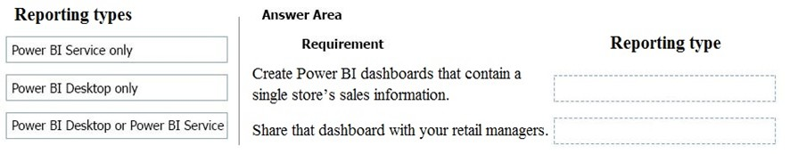

Correct Answer:
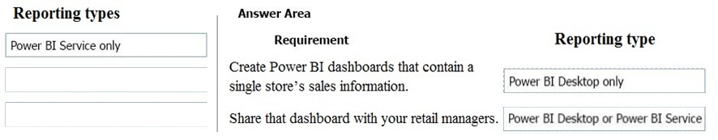
Reference:
https://docs.microsoft.com/en-us/power-bi/fundamentals/desktop-getting-started

uestion Discussion8 ChatGPT
Share

Question #69

DRAG DROP -
A company uses Microsoft Excel workbooks to store consolidated sales data. Workbooks are stored on OneDrive for Business.
Match each Power BI feature to its requirement. To answer, drag the appropriate features from the column on the left to its requirement on the right. Each option may be used once, more than once, or not at all.
NOTE: Each correct match is worth one point.
Select and Place:
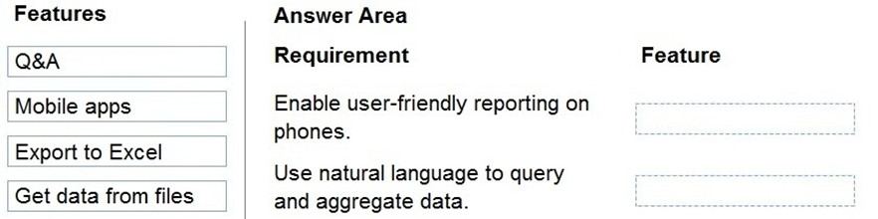

Correct Answer:
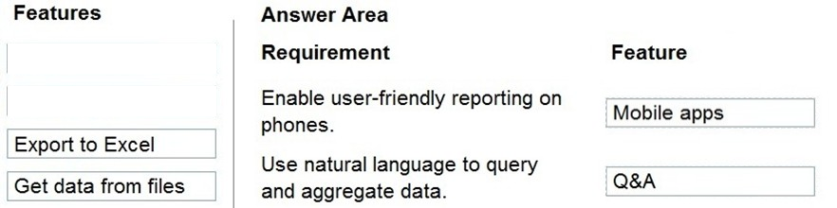
Reference:
https://docs.microsoft.com/en-us/power-bi/consumer/mobile/mobile-reports-in-the-mobile-apps

uestion Discussion32 ChatGPT
Share

Question #70

DRAG DROP -
A company plans to display support call metrics on a screen that is visible to all call center staff.
You need to recommend solutions to meet the company's requirements.
What should you recommend? To answer, drag the appropriate components to the correct requirements. Each component may be used once, more than once, or not at all. You may need to drag the split bar between panes or scroll to view content.
NOTE: Each correct selection is worth one point.
Select and Place:
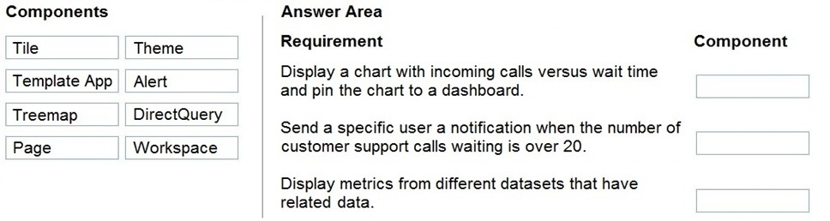

Correct Answer:
